ECEN 301
Embedded Systems

Study Guide
Supplementary Notes
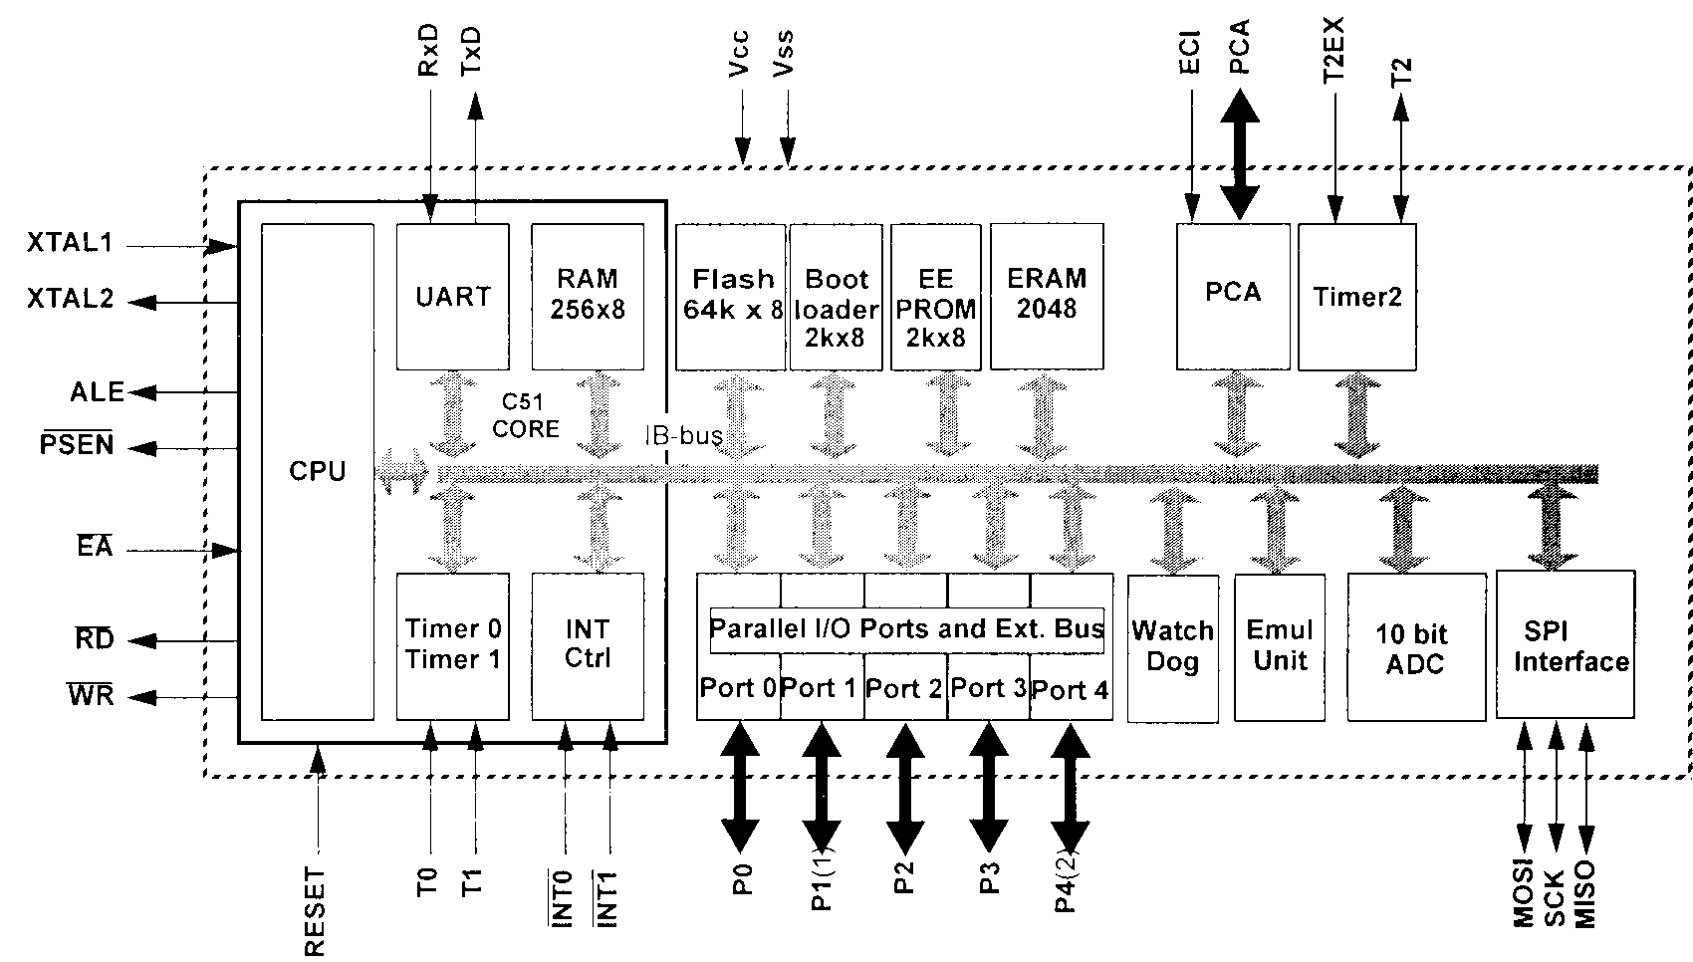

D.A. Carnegie

2020

This study guide is intended to assist students with note taking in the lectures for the courses ECEN 301. It is not intended to serve as a text book, but rather to supplement the material presented in the lectures. This study guide comprises additional material to complement the material presented in the lectures. You are expected to read through and understand these notes.

Hopefully I should have found most of the mistakes and typos in this guide. If you discover other errors in this guide please inform me so that they may be corrected, and you can earn a chocolate fish.

Dale Carnegie
Contents
Section 1 : Transducers
Introduction 1
Transducer Parameters 2
Software Interfacing 6
Resistive Sensing Elements 11
Potentiometer 11
Resistance Thermometers and Thermistors 14
Strain Gauges 19
Capacitive Sensing Elements 23
Elastic Sensing Elements 27
Inductive Displacement Elements 30
Hall Sensors 33
Self Generating Transducers 35
Thermocouples 35
Electromagnetic Effect 40
Piezo-Electric Effect 42
Photovoltaic Effect 43
Optical and Nuclear Sensors 44
Section 2 : Signal Conditioning
Voltage Dividers 46
Bridges 48
Op-Amp Circuit Theory 58
Filters 68
Passive 68
Active 77
Ideal Filter and Approximations 78
Time and Frequency Descriptions 82
Design of Active Filters 88
Voltage Controlled Voltage Source (VCVS) Filters 95
Other Active Filters 99
Digital Filtering 103

Basic Transducers and Signal Conditioning
Definition of transducer:
A device that converts one form of energy into another form; more usually used to refer to a device that produces an electrical output for an input from a particular physical variable (measurand).
General structure of a measurement system:

The words sensor and transducer are both widely used in the description of measurement systems. The former is popular in the USA whereas the latter is preferred in Europe. A sensible distinction is to use sensor for the sensing element itself and transducer for the sensing element plus any associated circuitry; for example a thermistor would be a sensor and a thermistor together with a bridge circuit (to convert resistance change into electrical voltage) would be a transducer. All transducers thus contain a sensor and most (though not all) sensors would also be transducers.
Since the conversion of energy from one form to another is an essential characteristic of the sensing process, it is useful to consider the various forms of energy. Each of the forms of energy has a corresponding signal associated with it, and for measurement purposes six types of signal are important.
(i) Radiant especially visible light or infra-red
(ii) Mechanical displacement, velocity, acceleration, force, pressure, flow …
(iii) Thermal temperature, heat flow, conduction …
(iv) Electrical voltage, current, resistance, dielectric constant …
(v) Magnetic magnetic flux, field strength …
(vi) Chemical chemical composition, pH value …

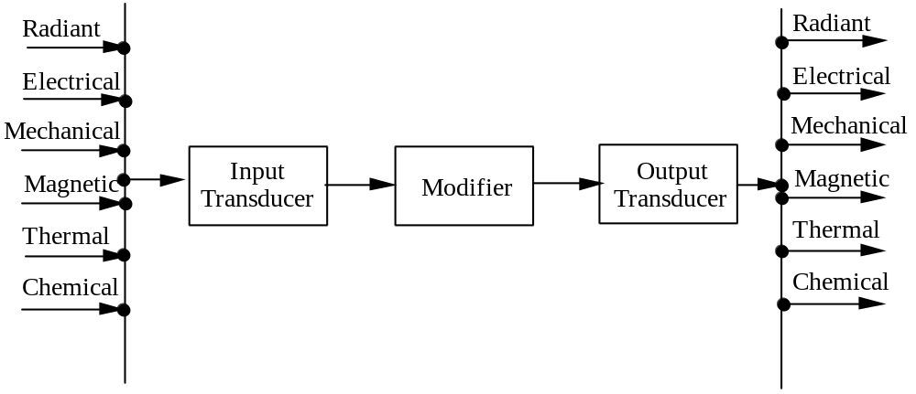
e.g. temperature from a hot body (thermal), converted to electrical energy, processed, and output to an LED (radiant).
Some transducers are said to be self exciting or self generating, meaning that their operation does not require the application of external energy, whereas others known as modulating transducers do require such a source of energy. For example, a thermocouple is self generating, producing an emf. in response to a temperature difference, whereas a photoconductive cell is modulating. Without an external source of energy a photoconductive cell simply responds to the input light energy but does not produce a useable signal; a signal is obtained by applying an electrical voltage and monitoring the resultant current.
Self-generating transducers usually produce very low output energy, having a low effective conversion efficiency; they are typically followed by amplifiers to increase the energy level to a suitable value. In contrast, for modulating transducers, a relatively large flow of electrical energy is controlled by a much smaller input signal energy.
Transducer Parameters
Sensitivity is often misused to indicate that the device either (a) produces a large output in response to a given input, or (b) if it is for example disturbed by people jumping near it. These are two totally separate issues.
The response of a transducer to an input signal is known as its responsivity r, defined by:
r =
For a displacement transducer the units would be V/m.
The noise produced by a transducer, which limits its ability to detect a given signal is known as its detectivity d, defined by:
d = =
The least detectable signal is defined as that input signal which produces an output r.m.s. signal-to-noise ratio of unity. This means that if, in the absence of an input signal, the transducer produces a certain output noise power N, then the least input signal that can be detected is that which produces an output signal power S equal to N (that is, doubles the total output power). Units are in reciprocal input signal units, e.g. 10⁶ m^{–1} for a displacement transducer which has a least detectable signal level of 10^{–6} m.
There are many other parameters such as response time, linearity, accuracy, repeatability, zero-offset, drift, sensitivity to disturbance, but they are mostly more applicable to complete measurement systems as opposed to transducers.
Signal Conditioning Element
The sensor or sensing element output is converted into a form suitable for further processing, e.g., amplifier converts microvolts to volts, deflection bridge converts impedance change into voltage change.
Signal Processing
The signal from the conditioning element is processed, either, into a more suitable form for presentation or by performing calculations on it before converting it into a suitable form for presentation.
Data Presentation Element
Examples are: VDU, galvanometer, alphanumeric display.
Sensing Elements
Active:
(no external power supply)
Electrical output
Passive: Resistive
(external Capacitive
power supply) Inductive

Elastic elements are often used as the primary sensing element (mechanical member: e.g. cantilever, diaphragm). This primary element is followed by a secondary sensing element: e.g., resistance or inductance to produce an electrical output.
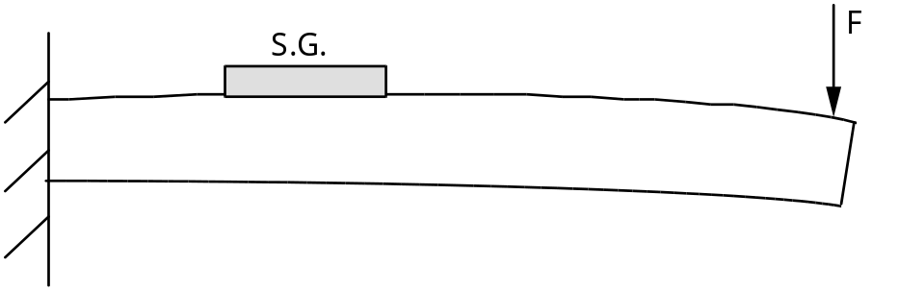
Force 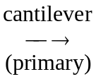 Strain 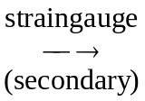 Resistance
Sensors and Microprocessors
Microprocessors are being used with sensors to make more accurate and reliable transducers. In most cases, it is now possible to place the microprocessor with the other electrical components within the sensor housing. The microprocessor then becomes user-invisible, just as the complex behaviour of the sensor is user-invisible.
The only real problem with microprocessors in these real-time applications is that they are sequential in operation (and hence ‘slow’) and the internal signals are discrete (in amplitude and time).
The ability of the processor to look at the output of a sensor and process this output means that the range of physical processes which can be used in sensors is extended. Also, changes in the sensor can be compensated for, e.g. drift and/or temperature; the latter by incorporating a temperature sensor with the sensor. The micro can be used to encode the sensor signal for transmission. This can be in a variety of forms; parallel, serial, frequency, phase and pulse width. The input/output mechanisms provide the instrumentation system designer with a wide choice:
1. event counting, using for example the interrupt request:
2. parallel port;
3. serial / USB port;
4. analogue port;
5. memory mapping.

Transducer imperfections can be overcome using microprocessors:
1. Frequency response: This is really a filtering problem which can be overcome using digital filters (either in firmware or software). Digital filters tend to be more stable and are more ideal than their analogue equivalents. A zero can be placed over every pole in the transducer response (and vice-versa). Time, however, may place a limitation on the level of filtering.
2. Non-linearity in the transducer (I/O) characteristics. The use of microprocessors for linearisation overcomes problems encountered previously when using analogue methods of linearisation or nulling. Look-up data can be set up automatically during calibration of the sensor.
3. Noise. Digital filtering (including averaging) can be used to overcome noise. Note has to be taken that sampling and quantisation are in themselves noisy processes.
4. Drift. This has always been something that has limited transducer applicability, and can also limit a transducer’s working range where potential sensitivities cannot be used. Because the microprocessor has a memory, then a drift-free reference value can be stored and hence parameter changes can be monitored and stored, and analysed ...).
Zero updating is also possible in order to overcome drift problems, as in a weighing instrument, when there is (periodically) a return to a zero input condition. Offset errors can be accounted for and nulled.
A calibration phase may be incorporated into the construction of the transducer, or if the input goes to or through a known value at a particular time then this can be used for calibration.
5. Cross-Sensitivity. Temperature, pressure, humidity, e-m fields may all produce spurious signal or parameter changes. Insulation and screening and/or a bridge can be used to balance out systematic changes. Here again digital processing (? sledgehammer) can be used but enough information regarding the transducer and how it responds to various ‘noise’ inputs needs to be obtained. Note that there is an application here for the sensor within a sensor technique.
For example, a strain gauge is sensitive to temperature changes. This is particularly true for silicon gauges. However, by also using a thermistor and multiplexing between the two sensors, a linear output of strain can be obtained. This method has been used to obtain a 0 to 3000 μstrain output to ±3 μstrain accuracy over a 20 °C to 50 °C temperature range.
Silicon sensors are now being constructed—the rationale being that the processor can be put onto the same chip as the sensor. Silicon has been used in the construction of accelerometers, piezo-resistors, photodiodes, Hall effect devices and gas or ionic sensors.
The transducer, though, is still a peripheral device to the microprocessor.
A significant advantage of using a microprocessor is that the microprocessor can communicate along a bus — and is thus addressable. This means that the transducer is addressable, and can be connected to a common bus and selectively addressed.
Various protocols are being discussed, but it will almost certainly be bit serial transmission of 8-bit data bytes in the standard universal asynchronous receiver/transmitter (UART) format.
The International Electrotechnical Commission (IEC) are drafting a set of functional requirements for a digital field bus standard, capable of operating in an industrial environment. These requirements assume that the field devices contain sufficient intelligence to perform simple monitoring or actuator functions, but they are too simple to require a MAP or Proway system bus connection. Power distribution may be via the same conductors, with up to thirty devices on the bus.
Software Interface for Transducers
Interface can be hardware, software or mixture of both.
e.g. For square wave frequency measurement we could drive an edge triggered interrupt directly and use software to measure time period between interrupts. Taking the reciprocal of this would give the frequency.
Alternatively using an external clock we could gate the square wave pulses into the micro for a fixed period of one second (say) and count them using software to provide a measure of frequency.
Finally we could employ an external counter and gate this with the external clock to obtain an indication of frequency directly from the counter for input to the computer. In most cases it is a mixture of software and hardware.
Performance trade off between software/hardware is that software slows process down but reduces component count.
However with advancing technology more and more functions are implemented on single chips at low cost and the trend is to transfer many interface algorithms onto the chip. (e.g. linearisation of a thermocouple.)
Whichever method is employed in a computer system, at some stage there must be an interface with the software.
In this section we shall look at some of the software techniques which should be employed between the controlling program and signals received from the system plant.
Programmed SOFT FAIL
Soft fail refers to the graceful degradation of a system when some of its components fail.
It is intended to prevent total failure when a limited malfunction occurs.
Type of Failure
Can be (a) Sensor failure
(b) Control device failure
(c) Power failure
(d) System failure

(a) Sensor Failure
May be temporary or permanent.
Temporary
Detected by reasonableness testing.
This refers to the use of a ‘bracket’ to determine whether a given input value is reasonable.
e.g. (i) In measurement of the temperature of liquid water values of 0 – 100 °C are reasonable.
(ii) Barometric pressures of 0.3 to 1.2 bar are reasonable.
Whenever unreasonable data is received it should be ignored by the control program.
In some cases the ‘reasonable data’ bracket may vary with time:—
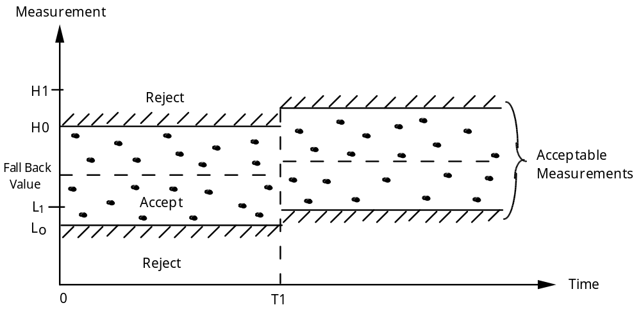
Microprocessor accepts only L-H measurements and signals rejected measurements
“Reasonableness” Testing
The ‘Fall back value’ represents an average value of the input data and this will be used as a back up value in the event of all input data becoming unavailable.
Permanent
A permanent failure of the detector is detected by the reasonableness test. It may be defined as permanent whenever the same sensor fails n times during a given time interval. At this point, the sensor should be ignored. It can be actually disconnected by software by weighting it to “0”, using the sensor weighting technique:
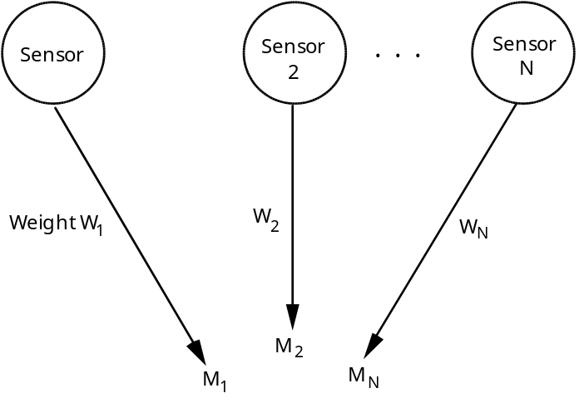
Weighted Measurement = 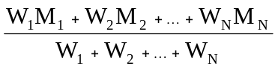
Automatic Disconnect W₁ = 0 if Sensor 1 is found “unreasonable” or non-operative
Optimization through Sensor Weighting
Usually, the sum of the W’s is set equal to 1.
For example, if three sensors are used to measure the temperature of a room, initially all three may have the weight of 0.333. However, after a time, it may be found that one of the sensors is positioned at the wrong location and that its indications should not be taken in as much consideration as the indications of the other two. At this point, its weight might be reduced to 0.1, while the weights of the other two are boosted to 0.45 each.
In order to disconnect by software a sensor which has been found to be “unreasonable”, its weight will simply be set to the value “0”. Referring to the equation above, it can be seen that the value provided by the sensor will be ignored as long as its weight is 0. If at some time in the future it is found to become reasonable again, it can be reconnected by software by changing its weight to a non-zero value.
Additionally, back-up average values may be used for a while for one of the sensors when it becomes unavailable, if its role was crucial to the operation of the system. Naturally, a diagnostic or an alarm can also be generated.
(b) Control Device Failure
Temporary Failure
The only reasonable way to detect the failure of a control device before actual harm is done requires monitoring it. A status-feedback is necessary. In order to detect whether a control device has executed an order, a tolerance bracket is usually necessary. For example, if a relay must be closed, a time period is tolerated during which the relay may close.
If a temporary malfunction is detected, the simplest method used is the “retry”. The order is simply given again, and again, up to a maximum of n times, until the control device obeys. If after n times it has not obeyed, or if such failure should occur too frequently in a given time period, it is deemed to be a permanent failure. Usually this simple retry method will provide the desired result.
Permanent Failure
In the case of control devices, and because of their high cost, alternate devices are not frequently available. If one is available, it should then be activated. If none are available, a back-up control strategy may be implemented which puts the system in a mode where it keeps operating at a reduced performance level. At the same time, a diagnostic or an alarm should be generated.
(c) Power Failure
A bootstrap program may be used to start the system in a table-driven scheduling mode. In this mode, the list of actions to be performed by the system is stored in a table. The system will revert to this mode of operation whenever a power failure has occurred in order to provide immediate resumption of activities in a given mode. It will be able to switch to another mode of activity once enough data have been accumulated to take reasonable action.
Naturally, backup batteries may be used to provide immunity from power failures for a limited period of time.
(d) System Failure
A system failure refers to a failure of the microprocessor system itself, or its subsystems. At this point, an alternate microprocessor or another backup device may take over.
The Software Protection Discipline
The above techniques should be used in any control system to provide reliable, safe, and efficient operation. By applying them systematically to all inputs and outputs in the system, they will result in improved performance of the overall system, especially in the case where some of the hardware interfaces may malfunction. Software design should be integrated with the overall interfacing design.
Summary
The possible layers of software protection are illustrated below.
The sensors and control devices appear on the left of the illustration. Both the measurements from the sensors and the orders to the control devices are tested for reasonableness. Additionally, the information from sensors is weighted, and may also be averaged before being passed as a parameter to the control algorithm. In the case of the control devices, status is monitored for possible malfunctions.
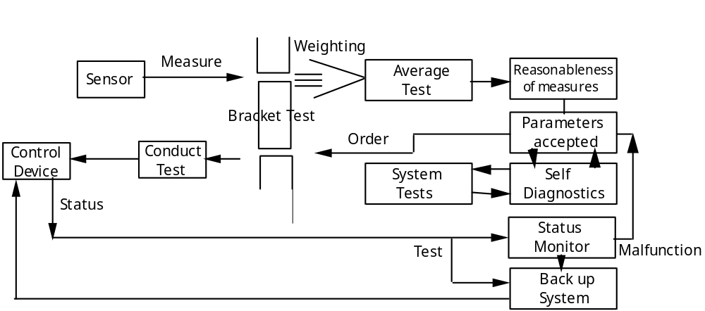
Multi-Level Protection
Resistive Sensing Elements
Potentiometer: cylindrical stator with either wire-wound track or film of conductive plastic. The resistance per unit length is constant so that the ratio of output voltage to supply voltage is proportional to the fractional displacement of slider.
Conducting plastic film have ‘zero’ resolution error but higher temperature coefficients of resistance. Hybrid track potentiometer: conductive plastic film on wire-wound resistance track.
Loading Effects (using [resistive linear displacement transducer] as an example).
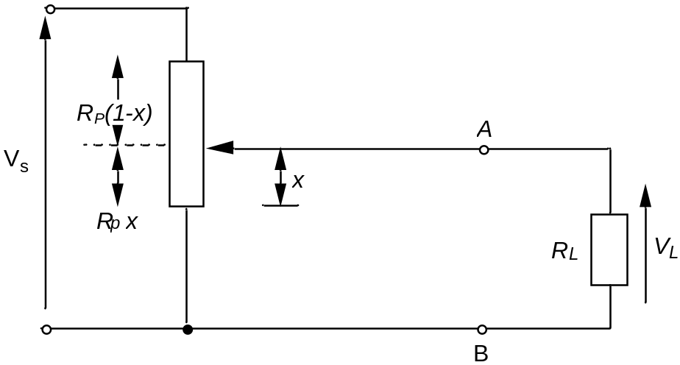
Note that x is expressed as some fraction along R_{p}
Redrawing, separating R_{p} and R_{p}(1–x):
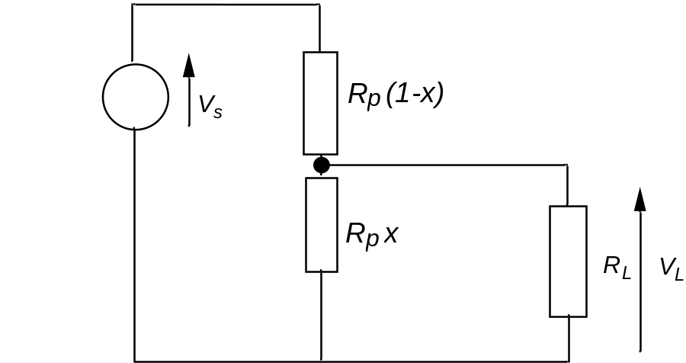
Output (or load) resistance = R// Rx
Total resistance = R_{p}(1–x) + Rx // R
= 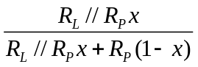
R// Rx =
so
= 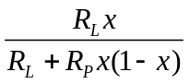
hence
V= Vs x . 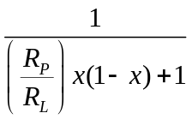
Error introduced by loading potentiometer is given by:
N(x) = V_{s} (O/C) x – V
∴ N(x) = V_{s}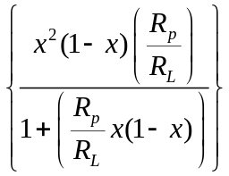
If 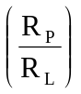 << 1, then:
N(x) = 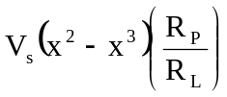 , noting that x < 1 and therefore x< x.
N(x) is a maximum when x = and N(x)= 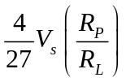 .
As a percentage of full-scale output,
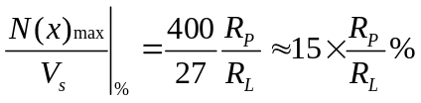 .
Thus for 1% or less error, .
Example:
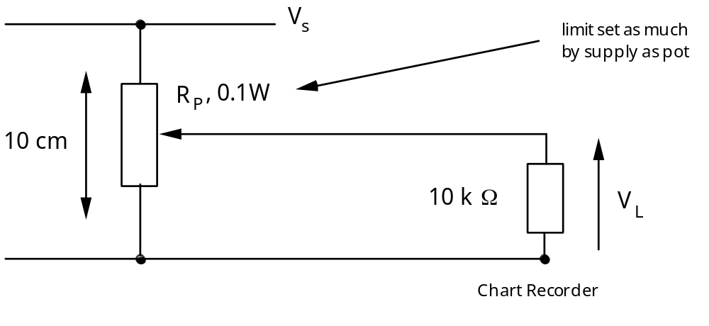
For maximum non-linearity of 2%
15 . ≤ 2 ∴ R≤ = 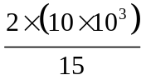
and thus R_{p} = 1 kΩ is suitable.
If 0.1 W is max. power dissipated: = power dissipated
= 0.1 W, ∴ V= 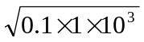
= 10 Volts
Examples of the loading effect occur in other areas: differential pressure transducer producing a current proportional to pressure, strain gauge bridge being loaded by amplifier.
Resistance Thermometers and Thermistors
Most thermal modulators are devices whose resistance changes in response to temperature. Both metallic and semiconductor sensors are widely used, though their characteristics differ greatly due to the differences in the energy gap between the conduction and valence bands. The resistivity of most materials can be written as
ρ_{T} = ρ∞exp 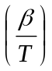
where ρ_{T} is the resistivity at temperature T, ρ∞ that at very high temperature and β a constant proportional to the energy gap. Considering two temperatures T₁ and a reference temperature T₀, we can eliminate ρ∞ and express the bulk resistance as:
R_{T} = R₀ exp 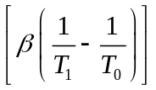
R₀ is the resistance at the reference temperature T₀. For semiconductors β is relatively large and positive, typically several thousand. The change in resistance with temperature is very non-linear which does pose some problems. Most of the semiconductor devices are known as negative temperature-coefficient (NTC) thermistors, since the slope of the curve is negative. In the case of metals, where there is a negligible energy gap, the constant β can be considered to be small and negative so the exponential in the previous equation can be simplified to give:
R_{T} ≈ R₀ [1 + α(T₁ – T₀)]
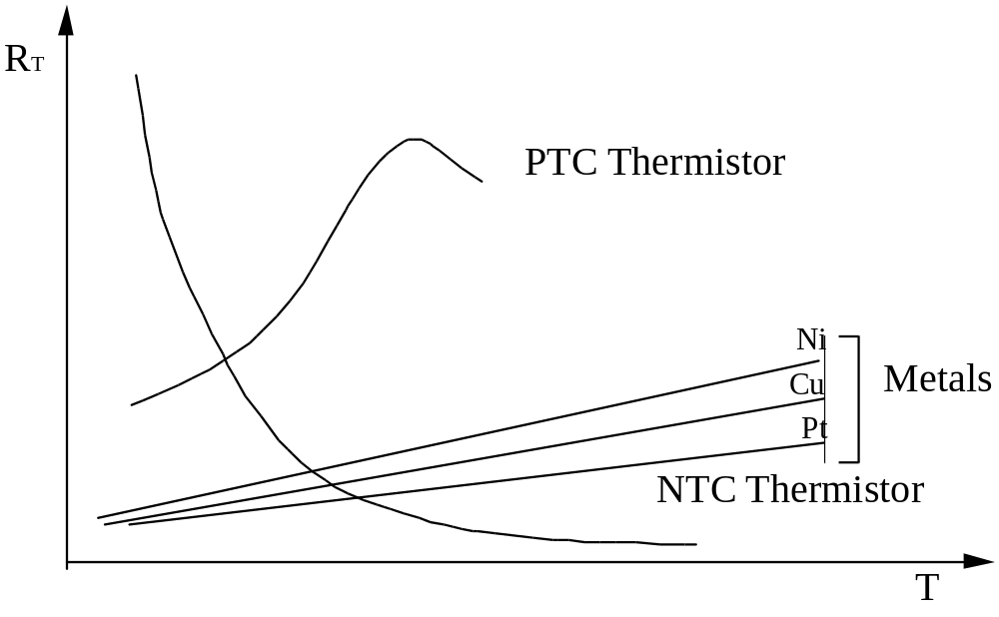

Resistive Temperature Transducers (metal):
More formally, for most metals the change in resistance with temperature is reasonably linear between –100 °C and +800 °C.
R_{T} = R₀ (1 + αT + βT² + γT³ + ...) ,
R₀ is resistance at temperature 0 °C and α, β, γ are temperature coefficients; generally, β and γ are much smaller than α and can be ignored.
These transducers are rather like wire-wound resistors, being in the form of a non-inductively wound coil of a suitable metal wire.
Typically platinum, copper or nickel are used, although platinum is preferred for (industrial) resistance thermometers. It is chemically inert (relatively) and has linear and repeatable resistance–temperature characteristics (i.e. large relative to β and γ), it can be used over a wide temperature range (–200 °C to +900 °C) (c.f. -200° to 300 °C for copper) and in many environments. It can be refined to a high degree of purity; this means that there are only small variations in resistance between similar elements. Their main disadvantages are that they are relatively large, and so have a large time constant. Their responsivity is low, ranging from 0.4Ω °C^{–1} for platinum to about 0.7Ω °C^{–1} for nickel (for a 100 Ω device).
Typically (for platinum): R₀ = 100 Ω, R₁₀₀ = 138.50 Ω, R₂₀₀ = 177.30 Ω, α = 3.92 ×
10^{–3} °C^{–1}, β = –5.85 × 10^{–7} °C^{–1}, i.e.
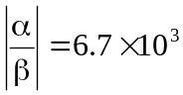,
R_{T} = R₀ (1 + αT) ⇒ = αR₀ = 0.39 Ω °C^{–1}
The fundamental interval, (R₁₀₀ – R₀), for this device is 38.5 Ω and the maximum non-linearity is +0.76 per cent fsd. (0 to 200 °C).
Note that self-heating due to the measuring current is likely to cause errors and therefore should be avoided. Hence there will be a limit on the permissible current; 10 mW produces a change of 0.3 °C. The heat conductivity of the medium around the element should be as high as possible.
Resistance sensors are used with extra extension leads to cancel out the errors caused by lead resistance. In a conventional Wheatstone bridge, lead resistances add to the sensor resistance in series. This resistance will be a variable dependent on the temperature gradients along the connecting wiring.
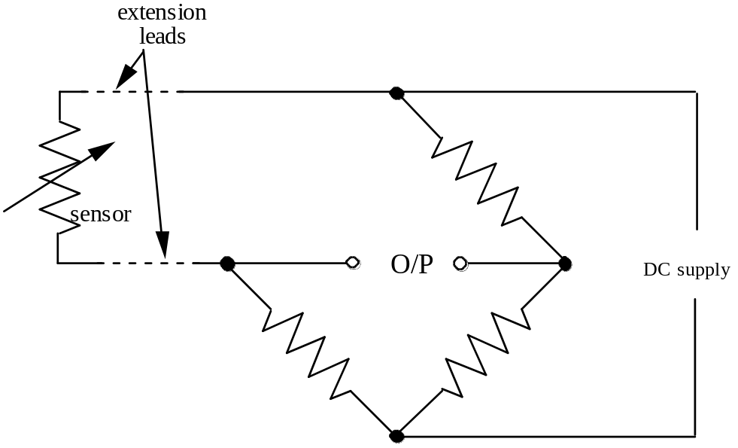
The Callendar-Griffiths bridge uses two leads from one end of the sensor thus balancing out lead resistance. This is commonly employed in industry.
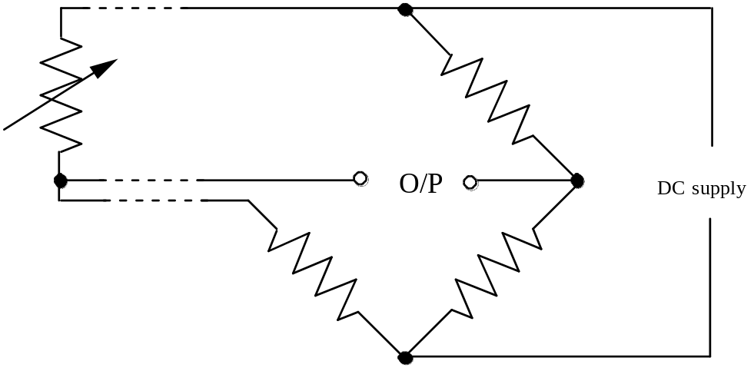
To eliminate all lead errors, a Mueller bridge is used. The two readings are averaged.
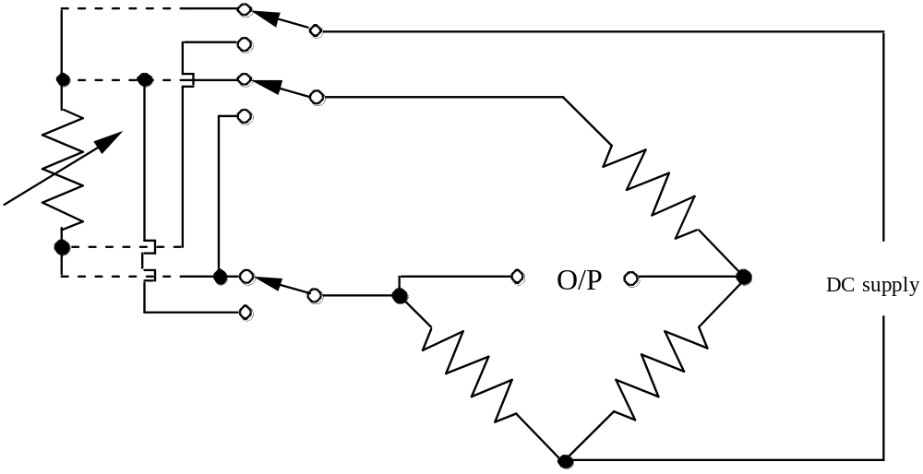
An alternative way of looking at the amplifier configuration is shown below. In order to overcome the temperature dependent resistance of the connecting leads having an effect on the measurement, simple compensating leads are used. These are identical to the leads used for the resistance element, but are short-circuited at the thermometer end, and connected in series with the standard comparison resistor in a bridge connection. In this arrangement the cable between the bridge and the sensor has four cores, twisted together for minimum noise pickup and screened with a conducting braid. Note that it is important to restrict the bridge supply voltage so that the current passing through the resistance coil is too low to heat it up materially and so cause an error.
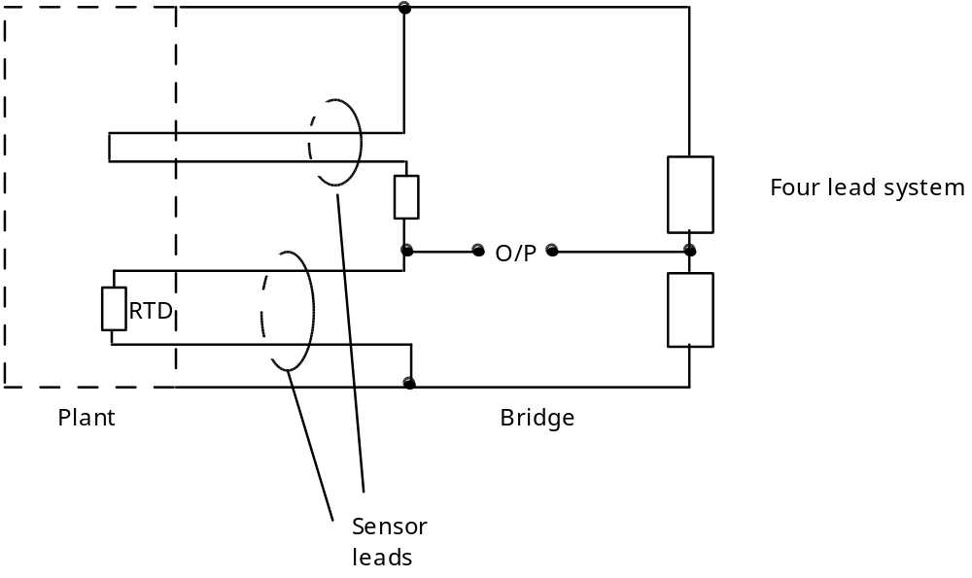
Where maximum accuracy is required, the small non-linearity in the temperature/resistance relationship must be taken into account, and the wire itself must not be subject to mechanical stress, else a strain gauge will result.
Thermistors
These are ‘RTDs’ made from semi-conductor material; the material is commonly oxides of chromium, manganese, iron, cobalt and nickel—powdered, sintered. Usually negative temperature co-efficient—highly non-linear. Thermistors have the advantages of high responsivity and small mass (about 400 times greater responsivity than an IC thermocouple). However, besides being non-linear, their characteristics may vary appreciably from sample to sample and they have a limited temperature range of about -100 °C to 200 °C. Non-linearity is no longer considered to be much of a disadvantage since transducers are being more often connected directly to microprocessors, so that the response characteristics can be compensated in software. However, one of the most suitable thermistor applications is in temperature control, where linearity is less important than their high responsivity, enabling high detectivities to be achieved.
Thermistors are usually operated in bridge circuits, and compensating leads are not usually needed because of their reasonably large resistance. Some care has to be taken in limiting the power dissipated, which can seriously affect the measurement because of their small thermal capacitance.
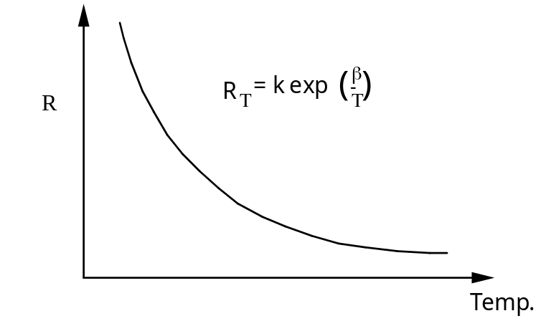 | or  R_{T} = R₀ exp  R₀ is resistance at reference temperature T₀ and β is a material constant (of the order of 3000 – 4000).
As an example:
R (25 °C) = 12 kΩ, R (100 °C) = 0.95 kΩ, β = 3750
1 °C rise in temperature for 7 mW I/P power.
Thermistors have a fast response time, typically of the order of milliseconds. They exhibit the highest sensitivity amongst temperature transducers, but they are inherently non-linear, and hence tend to have a very limited working range. Their small size and fast response times make them ideal for use in medical applications (e.g. maybe inserted in the nose to detect breathing, as exhalation warms the device, inhalation cools it).
Strain gauges
Strain gauges are among the most commonly employed sensing element. They are typically used to measure an applied force, or similarly pressure (when mounted on a diaphragm). When a force is applied to an elastic material, that material will deform. Elasticity is the ability of a material to recover its original shape and size after a deformation. The applied force can be either positive tensile or a negative compressive. Tensile stress produces elongation, compressive stress produces shortening. Providing the material remains elastic (i.e. the force is not too large), the change in length is proportional to the applied force, and may be given by Hooke's Law:
F ∝ ΔL

Substances like clay have no elasticity, and are referred to as plastic materials.
Mechanics: Stress = , S =
The deformation of a material depends on its length, cross-sectional area, and composition. Considering the effect of length first:
Stress produces strain: the change in length, or strain is defined as ε_{L} = 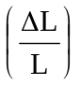 , and is along the same axis (i.e. in the same direction) as the applied force (L is the unstressed length). This is known as the axial or longitudinal strain. Note that the transverse strain is given by ε_{T} = 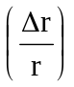 where r is the radius of the conductor (also given by a similar ratio of diameter). For most materials there is a range of applied stress over which the strain produced is linearly related to the stress, i.e. the change in length is proportional to the force, up to a certain limit. This limit is of the order of 10^{–6} in magnitude for mild steel (a very small number, so we tend to talk about microstrain, µε). For a strain greater than this, the material will be permanently deformed.
The greater the area of the object being deformed, the less the effect of the force on the strain. Hence
∝

where we have just expressed the change in length as a ratio.
To relate the composition of the material to the effect deformation has, we need to introduce a new term called the elastic modulus of the material. The elastic modulus (or Young’s modulus) of a material is defined as:
Ε = = 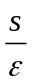,
where E is referred to as Young’s modulus. Young’s modulus is entirely dependent upon the material, including any heat treatment it may have had. We can now rid ourselves of the proportionality factor in Hooke’s law, to arrive at the equation
= E
For any given applied tensile stress, there will be an increase in length—a positive strain and since the total matter in the strained body is not increased, there is also a reduction or decrease in the transverse direction, i.e. a longitudinal tensile strain is accompanied by a transverse compressive strain.
ε_{T} = – νε_{L},
where ν is Poisson’s ratio. Typically, ν is between 0.25 and 0.4 for most materials.
Note that we originally defined stress as force divided by area (). Stress can be referred to by the symbol S, or alternatively σ. So obviously
S = Eε
Strain is usually measured electrically, using the fact that the resistance of a conductor changes when it is stressed or compressed. It is important to ensure that as far as possible strain is the only factor that causes a resistance change, so the material used is chosen to have a low temperature coefficient of resistance, for example copper-nickel or nickel-chromium alloys. Hence we use strain gauges, made from an appropriate metal or semiconductor, whose resistance changes with applied strain.
The conductor is usually fabricated as a thin foil bonded to a thin insulating film, which in turn is glued to the component under test. In order to minimise the effect of temperature, two foil strain gauge elements are often used differentially, one in compression, and the other in tension. A simple layout of a typical foil gauge is shown below. Note that there are many different variations on this layout, depending upon the application.
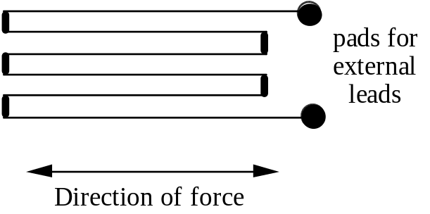
Taking as a simple device, a cylindrical conductor, the bulk resistance is given by
R = , R = resistance in Ω
L = length, m
A = cross-sectional area, m
ρ = resistivity of conductor

and
= . + . – . ,
where ε is the strain
∴ = . + . – . .
or
= + –
But is strain-induced changes in resistivity (piezo resistivity),
is longitudinal strain (ε)
and is transverse strain ε
Hence: = ε+ 2 ν ε+
= ε+
and the gauge factor for a strain gauge is given by:
G = ratio of the relative change in resistance to the relative change in length,
G = = 1 + 2 ν + . .

The second term on the RHS is known as the dimensional term, and the third as the piezoresistive term. This term is about 0.4 and ν is of the order of 0.2 to 0.5, and thus for most metals, G ≈ 2.0.
The metal used for strain gauges is an alloy called Advance: 54% Cu, 44% Ni and 1% Mg. This alloy has a low temperature coefficient of resistance (2 × 10^{–5} °C^{–1}) and a low temperature coefficient of expansion. This minimises the temperature effects (i.e. do not want to use SG as RTD!) but note that different strain gauges used for different substrates.
Typically, strain gauges are made by photo-etching a very thin metal foil into a grid structure and mounting this on a resin film base. They are sold packaged like this; the whole structure is then bonded—using suitable adhesive—onto the substrate. Note that an active and transverse axis exists (transverse axis also known as passive axis). Gauge constructed so that ΔR is ‘large’ due to strain along active axis and small due to strain along transverse axis—although cross-sensitivity can be important.
Nominal values: G = 2.0 to 2.2, R = 120 ± 1 Ω ± 0.3% linearity, 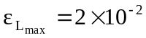 (tensile) and 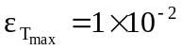 (compressive), T_{max} = 150 °C. ΔR_{max} = 4.8 Ω (tensile) ∫ 4%, I_{max} can be between 15 mA and 100 mA, in order to avoid self-heating.
Where small values of strain are involved, higher bridge sensitivity is desirable, and semi-conductor strain gauges can then be used. These have far larger gauge factors (typically 100, due to a large piezoresistive effect, which therefore dominates), so they produce an unbalanced signal that is 50 times greater than metal gauges for the same strain. Their disadvantage is their greater sensitivity to temperature changes. As with resistance thermometers, the current through them must be limited to 10 - 40 mA to avoid causing errors due to self-heating.
In addition to the resistance change in the gauge caused by temperature variation, a further error arises from differential expansion. If the temperature rises, the gauge and the object to which it is attached would normally expand by different amounts. However, when they are firmly glued together, that gauge must expand by the same amount as the test object, hence temperature changes alone will produce strains in the gauge and so an output from the bridge.
In order to avoid this error, manufacturers usually try to make the error caused by temperature strain balance the opposite error arising from the resistance change with temperature in an unstressed gauge. This balance will depend upon the material used for the test object, and manufacturers usually offer this automatic temperature compensation for three materials
mild steel
stainless steel
aluminium

A further source of error arises from the change in resistance of the connecting leads with temperature changes. These are usually reduced by using additional compensating leads in another branch of the bridge circuit so that, so long as both sets of leads experience the same change in resistance, the bridge output will be unaffected. This condition can be satisfied by using identical wires for all of the leads, and twisting them tightly together so that they will have the same thermal environment.
In some cases the balancing can be carried further by using two gauges in opposition, one of which experiences tension, and the other compression. This is possible where the load causes bending stress, as in a cantilever beam, or in a ring gauge. Indeed it is not uncommon for four gauges to take the place of the resistive elements in the bridge network.
Semiconductor gauges are very sensitive to temperature.
G can be +100 to +175 (P) (not uncommon)
or –100 to –140 (N-type)

As temperature rises, gauge factor falls: 0 → 40 °C, G changes by 12%, while resistance increases by about 4%.
Capacitive Sensing Elements
Parallel plate capacitor:
C = , C = capacitance, F
A = area of plate, m².
d = distance between plates, m,
ε_{ο} = 8.854 × 10^{–12} F m^{–1}, the permittivity of free space
ε_{r} = dielectric constant for material.

This is the basis for all capacitors; changing any of the parameters changes capacitance.

The capacitance of a parallel plate system can be made to depend upon displacement in several ways. The method generally used is to vary the spacing d. The transducer is usually built into a bridge circuit which only needs a few volts excitation. Thus the spacing between the plates can be very small, since an airgap of only 10 μm would sustain a potential of 10 V. This method of using capacitance sensing is thus most convenient for small displacements where other methods are less effective. Reactive bridges can sense to less than 10^{–5} pF.
The capacitance of a variable separation displacement sensor is
C = = 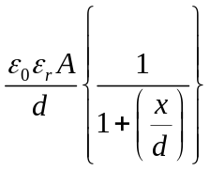,
and this is obviously non-linear. Note that x is the displacement from the equilibrium position, and the second form of this expression is only to clearly demonstrate the non linearity with variations in x. However, if d changes by no more than say 10%, the error introduced is usually tolerable. Otherwise, if the output of the bridge feeds a microprocessor, the non-linearity may be allowed for in the computer program.
An advantage of capacitance sensing over the LVDT is that the electrodes can be very light, consisting of thin metal foils or thin metal layers deposited on an insulator made of ceramic material. They can thus be used on light, rapidly moving objects without imposing excessive inertial loading.
Another way of making the capacitance vary with movement is to change the area of overlap of the plates. This is often done with a transducer comprising two concentric tubes, with one tube allowed to move axially with respect to the other. This technique gives a linear relation between the displacement and the change in capacitance, but is less sensitive than the method in which the spacing is altered.
There is also the possibility of changing the capacitance by altering ε_{r}. This can be used for example to detect the level of liquid in a tank, providing the liquid is an electrical insulator with a relative permittivity substantially greater than 1 (e.g. oil has ε_{r} of about 2.2). This type of transducer is usually connected to a bridge circuit which is balanced with the tank empty. The out-of-balance signal is then proportional to the depth of liquid in the tank.
With a variable dielectric; the area is proportional to the displacement,
C = A₁ + A
and A₁ = wx and A= w(l – x), A = wl
then: 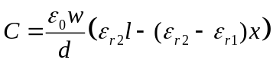, (to a first approximation).
Capacitance pressure transducer with a clamped diaphragm.
A one-sided fluid pressure causes deflection in a diaphragm.
In a pressure transducer of this type the diaphragm thickness is small compared with the diameter but there is no initial radial stress. Bending forces are the only forces considered, as stresses in the plane of the diaphragm will only count at large deflections, and hence are ignored in these calculations.
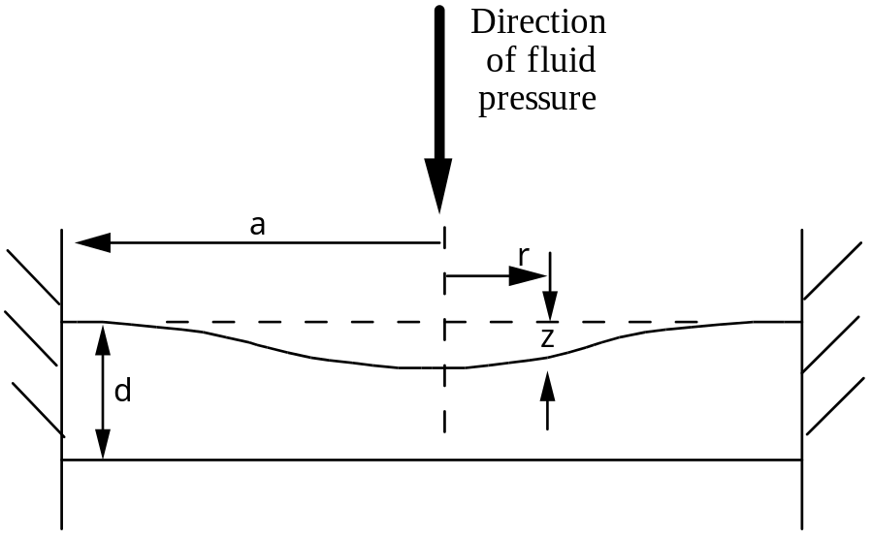
The deflection z at any radius r of a clamped diaphragm is
z = metres.
z is the deflection at distance r from centre of diaphragm of radius a and thickness t, made of material with a Young’s modulus E and Poisson’s ratio ν, subjected to a fluid pressure P pascals. Note in this case, the deflection z is linearly dependent upon the applied pressure P (for small pressures).
If the initial plate separation is d and the corresponding capacitance C = , then the fractional change in capacitance is given by:
C + ΔC =
Substituting for z, the fractional change in capacitance becomes
= .
Non-linearities in capacitive transducers in general can, to some extent, be overcome by using a push-pull arrangement,
C= 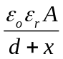, C= 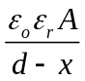
incorporated into a bridge.
Advantages of capacitive transducers
light-weight
very high detectivity
relatively low cost
excellent frequency response
operates over wide temperature range

Disadvantages of capacitive transducers:
high frequencies are needed
high impedance output
series (and/or parallel) resistance and cable capacitance may interfere
affected by environmental factors, e.g. humidity, temperature
Other Sensing Elements
Elastic Sensing Element
Elastic sensing elements:
T = Fd Torque
P = Pressure
a = Acceleration.
Elastic sensing elements are used as primary sensors. They have inherent spring, mass and damping characteristics, and can be modelled as a spring-mass-damper system with the equation
F = Ma + Dv + Kx
= M\S\up8(..)+ D\s\up8(.)+ Kx
which after Laplace transforming and rearranging gives the transfer function
G(s) =
ωn = and ξ = .
This equation also appears as
= K
noting that ω_{n} is the natural frequency
ξ is the damping constant
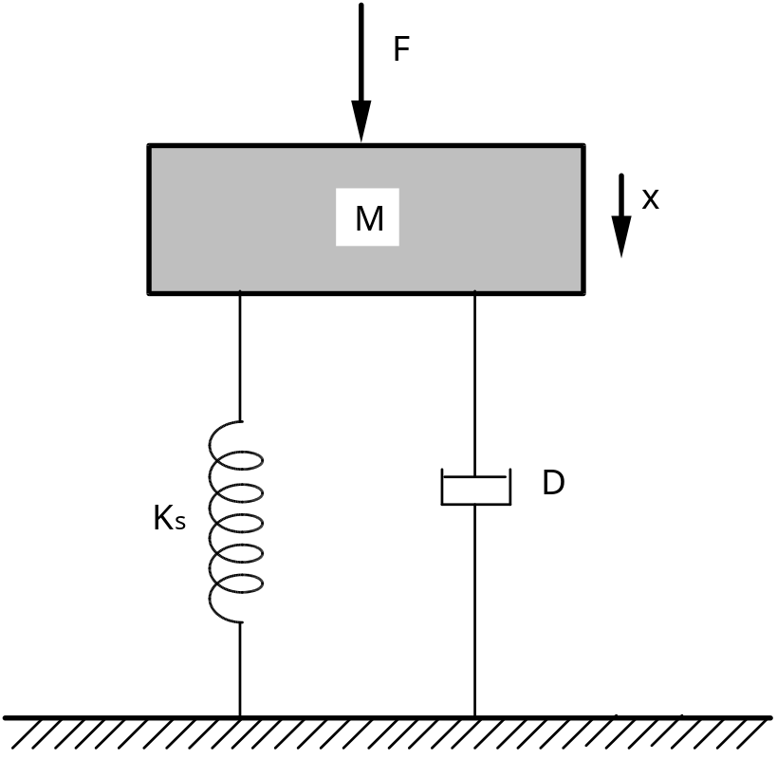
Optimum value for ξ = 0.7—minimum settling time for step I/P. G(jω) should be near to unity. Damping in many sensors, e.g. accelerometer is often adjusted to achieve these values (in particular ξ).
Diaphragms and other pressure sensitive elastic elements have only air damping and hence ξ \S\up3(~)0.1. Sensor ω_{n} has to be much higher than maximum signal frequency. However, increasing ω_{n} and having low ξ implies reducing steady-state sensitivity, and thus implying the need for a more sensitive secondary transducer.
The two basic elastic sensing elements are the
(i) cantilever
and (ii) diaphragm.
The strain due to a force F is
ε = 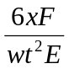
where x is the distance to the gauge centre
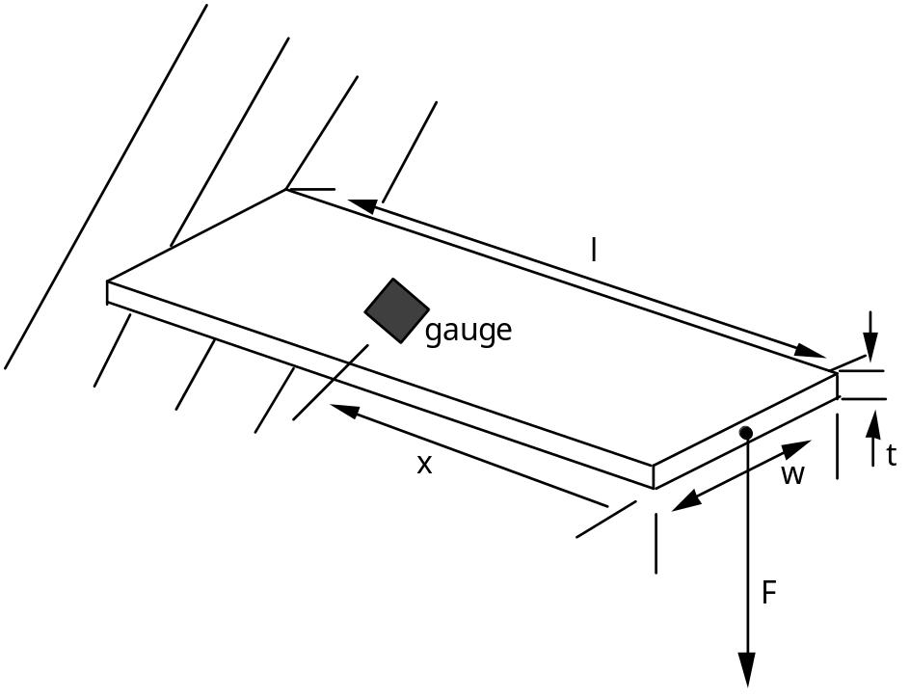
For a four-element strain-gauge bridge:
ΔR = GR_{o} ε for each gauge
and R = R_{o} ± ΔR = R_{o} (1 ± Gε); bearing in mind that two gauges are subjected to tensile strain and two (other) gauges are subject to compressive strain.
For the diaphragm:
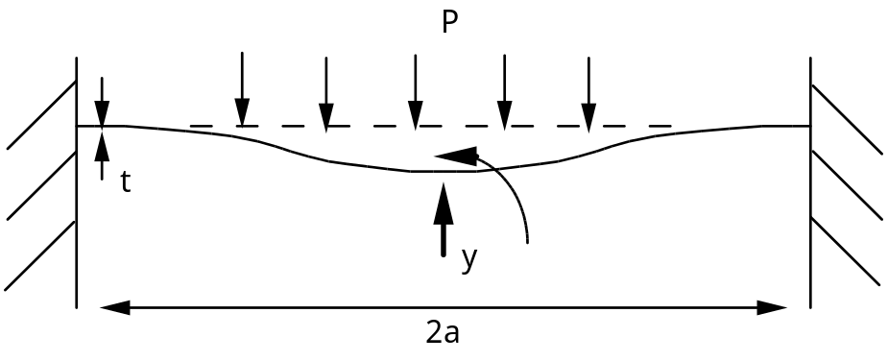
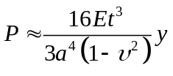
E = Young’s modulus
ν = Poisson’s ratio
y = the maximal (centre) displacement

Inductive Displacement Transducers
Magnetic circuit:
Mmf (F) = Magnetomotive Force
= flux and reluctance
(V = IR)
F = ΦS
where Φ is the flux of the circuit in webers, and S is the reluctance of the circuit in ampere turns/weber.
The self inductance of the coil L, is measured in henries, and is the total flux per unit current
L = =
Consider a basic magnetic circuit:
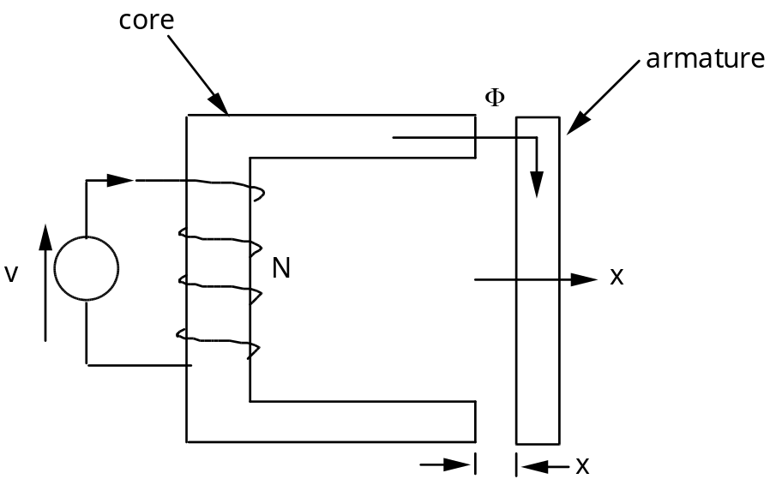 | NI = ΦS  and S = Siron+ Sair  = +  to a first approximation)
but μr \S\up2(~)1000 (say: typically 500 → 3000) thus we can ignore the contribution from the iron and state that S depends on air gap, 2x,
and thus: L = = to a first approximation.
More exactly the coil inductance is: L = =

(assuming contribution from the iron is constant and only the air contribution to the reluctance will change) where L_{o} is inductance at zero displacement, d = 0, and α is a constant.

To improve linearity, use a push-pull arrangement and (use) a deflection bridge:
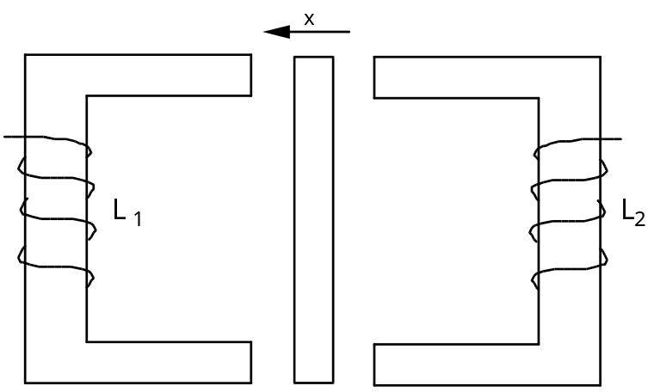 | L1 = ,  L2 =

Inductive transducers are widely used in industry, since they are compact and robust. Compared with capacitive devices, they are less easily affected by environmental factors such as humidity, and dust, but have a lower detectivity, hence tend not to be used for very precise measurements. The advantage it has over a resistive potentiometer is that no sliding contact is needed, so that it can operate in chemically active and dusty atmospheres which would soon prevent the slider of a potentiometer making adequate contact with the element.
The linear variable differential transformer (LVDT) is used for linear motion up to about 0.9 metres. The general arrangement is shown below.
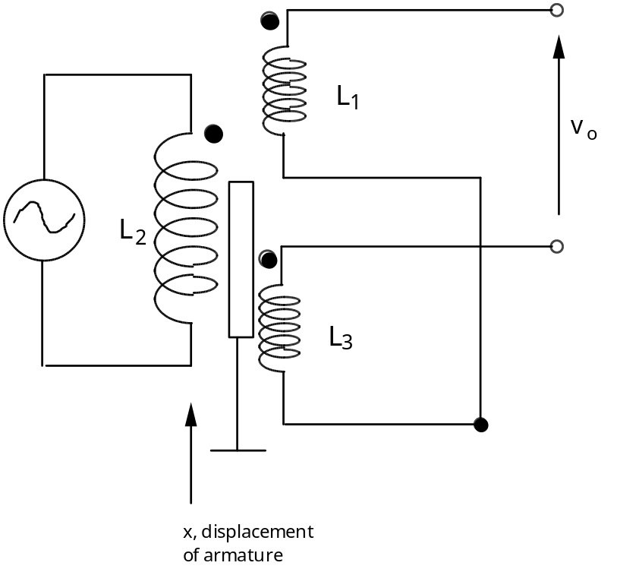 | The armature is a ferromagnetic core or plunger; the mutual inductance between primary and secondary coils depends on the position of the armature.
Note the dot notation. This is a convenient method of indicating the relative polarities of mutual induced emfs in magnetically coupled coils. In this notation a dot is arbitrarily placed at one end of the primary winding, and a second dot is then placed at the end of the magnetically coupled coil which has the same instantaneous polarity as the ‘dotted’ end of the primary winding.
The LVDTs are probably the most widely available displacement transducer, being very robust, yet capable of detecting displacements in the nanometre range. They comprise a transformer in which the coupling between primary and split secondary depends on the position of a ferromagnetic plunger. The two halves of the secondary winding are connected in series opposition, and are symmetrically placed with relation to the central coil L₂. This primary winding is energised by an oscillator at a frequency of 5-10 kHz. As the iron core moves along the axis of the coils, it varies the mutual inductance between L₂ and the output coils, and thus varies the emfs induced in L₁ and L₃.
When the core is in a central position, equal emfs are induced in the output coils L₁ and L₃, and as these are connected in series opposition, the nett output signal will be zero. As the core moves away from this central position, the nett emf. induced in the output coils increases in proportion to the displacement, but with opposite sign (determined by sending the output to a phase-sensitive detector).
Typical linearity errors are generally less than 0.5 - 1%. Note that a commercially bought LVDT may come in a dc-dc configuration. This has internal electronic circuits which include an oscillator to generate the 5-10 kHz excitation signal, and a phase-sensitive detector with smoothing. The power needed is typically 6-10 V d.c. at 50mA, and the output is a smoothed d.c. signal.
Hall Effect
When electrons moving through a vacuum pass through a magnetic field perpendicular to their direction of motion, they experience a force which deflects them in a plane perpendicular to both their initial motion and to the magnetic field. This is the basis of the deflection coils that are used to move the luminescent spot so as to produce a picture in a television receiver. The same force acts upon an electron moving in a metal but, as it collides frequently with the atoms of the metal, the observed deflection is very much smaller. This is known as the Hall effect.
This effect is negligibly small in metals (low resistivity) and insulators (low mobility) [see below] but is appreciable in semiconductors. Common silicon may be used but this effect may be increased by a factor of several thousand by using a semiconductor material such as indium antimonide, but currently many Hall effect devices use silicon so that the associated circuitry can be integrated onto the same chip. The Hall effect is smaller with silicon, but is typically in the range of millivolts. The effect is usually sensed by passing a current through a thin film of material which has electrodes attached on opposite sides. When located accurately, no potential difference will be measured between them as the current is flowing exactly perpendicular. However, upon introduction of a magnetic field perpendicular to the plane of the film, the lines of flow will be curved, and a potential difference will develop between the electrodes. This potential difference will be proportional to the product of the magnetic field strength, the control current and the cosine of the phase angle between the control current and the magnetic flux.
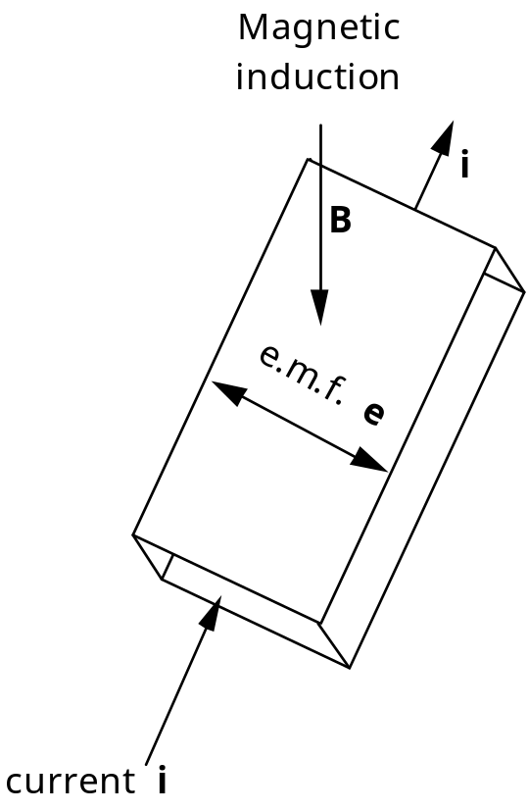
For a conductor of thickness t, the emf is given by
e =
where K_{H} is the Hall coefficient, dependent on the product of the charge mobility and resistivity of the conductor.
When the Hall sensor and the associated circuitry are constructed on the same chip, the transducer becomes very fast, and can respond at up to 100 kHz. Bouncing is also minimised, eliminating the need for “de-bounce” circuits somewhere else in the data acquisition system. There are no moving parts, resulting in high reliability, and can be used in explosive atmospheres where a mechanical switch might cause a spark. They are, however, rather susceptible to temperature changes, and must often be combined with a thermistor to enable temperature compensation. The strong temperature dependence means that the detectivities obtained tend to be rather low.
Self Generating Transducers
Self-generating transducers produce their own voltage from an external stimulus (such as motion or heat). Anyone who owns a turntable has one of these self generating transducers. We shall discuss a few examples of these transducers and the physical effects which are responsible for their operation.
Thermo-electric effect
Thermocouples
The high accuracy obtainable from platinum resistance thermometers is rarely essential for industrial controls, and hence a cheaper alternative such as the thermocouple is typically employed. This consists of two wires made of dissimilar metals joined together, with a break in the circuit to allow the emf to be measured. Then the two junctions are held at different temperatures, an emf is generated which is almost proportional to the temperature difference.
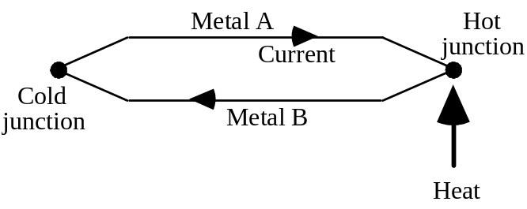
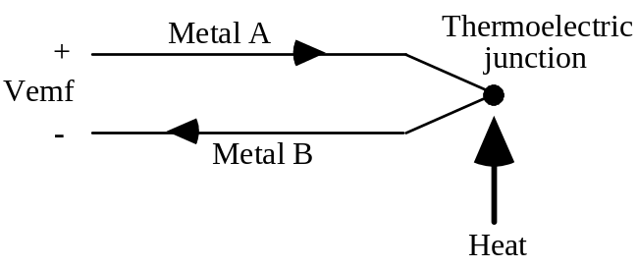
This is known as the Seebeck effect. Thus if the cold junction is held at 0 °C, a millivoltmeter connected across the break can be calibrated to read the temperature of the hot junction. For input to a microprocessor system, the signal must be amplified by a directly coupled amplifier that has a low zero drift, before being fed into an ADC. This is due to the output of the thermocouple being about 20 – 50 mV, depending upon the materials used and the operating temperature. The Seebeck voltage cannot be measured directly; if instrument leads are connected to the circuit, the leads themselves produce additional junctions, known as cold junctions or reference junctions, where they connect to the thermocouple leads. However, if these junctions are kept at a known temperature, their effect can be subtracted from the total voltage.
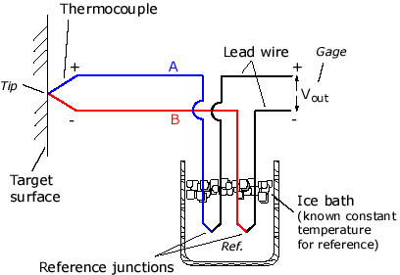
The most popular materials are platinum/platinum-rhodium, which is the standard device, Copper/Constantan and Chromel/Alumel. The output is around 6 μV°C^{–1} for the former to 60 μV°C^{–1} for the latter. Thermocouples tend to have a very wide working temperature range, nominally -180 °C to 1250 °C for Chromel/Alumel and up to 2000 °C or more for some alloys of tungsten.
Thermocouples are designated by letter types. The common metals (called base metals) are ANSI (American National Standards Institute) types T, E, J, and K. The more exotic metals used are called noble metals. These are more expensive but are able to operate at higher temperatures and have high resistance to oxidation and corrosion. After the metal in the table below are (+) and (–) signs. The (+) polarity establishes the metal with the higher-energy state. Type E, J, K, and T are base-metal thermocouples and can be used up to about 1000 ºC. Type S, R, and B are noble-metal thermocouples and can be used up to about 2000 ºC

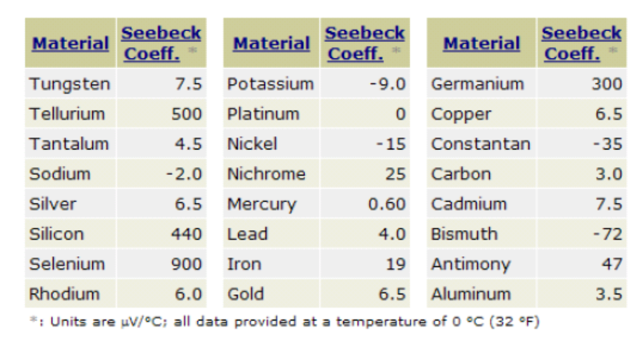

ISA | Material  (+ & -) | Temperature Range  °C  (°F) | Sensitivity@  25°C (77°F)  µV/°C  (µV/°F) | Error* | App.**
E | Chromel & Constantan  (Ni-Cr & Cu-Ni) | -270~1000  (-450~1800) | 60.9  (38.3) | LT:±1.67°C(±3°F)  HT:±0.5% | I,O
J | Iron & Constantan  (Fe & Cu-Ni) | -210~1200  (-350~2200) | 51.7  (28.7) | LT:±2.2~1.1°C(±4~2°F)  HT:±0.375~0.75% | I,O,R,V
K | Chromel & Alumel  (Ni-Cr & Ni-Al) | -270~1350  (-450~2500) | 40.6  (22.6) | LT:±2.2~1.1°C(±4~2°F)  HT:±0.375~0.75% | I,O
T | Copper & Constantan  (Cu & Cu-Ni) | -270~400  (-450~750) | 40.6  (22.6) | LT:±1~2%  HT:±1.5% or ±0.42°C(±0.75°F) | I,O,R,V
R | Platinum & 87% Platinum/ 13% Rhodium  (Pt & Pt-Rh) | -50~1750  (-60~3200) | 6  (3.3) | LT:±2.8°C(±5°F)  HT:±0.5% | I,O
S | Platinum & 90% Platinum/ 10% Rhodium  (Pt & Pt-Rh) | -50~1750  (-60~3200) | 6  (3.3) | LT:±2.8°C(±5°F)  HT:±0.5% | I,O
B | 70% Platinum/ 30% Rhodium & 94% Platinum/ 6% Rhodium  (Pt-Rh & Pt-Rh) | -50~1750  (-60~3200) | 6  (3.3) | LT:±2.8°C(±5°F)  HT:±0.5% | I,O

*: | LT = Low temperature range, HT = High temperature range

LT = low temperature range, HT = high temperature range
I = Inert media; O = oxidising media; R = reducing media; V = vacuum
Constantan, alumel, and chromel are trade names of their respective owners.
These values are approximations – the coefficient changes with heat (and with process).

Thermocouple | Seebeck Coefficient |  | Output Voltage at
Type | at 0°C | at 100°C | 100°C
B | -0.25 µV/°C | 0.90 µV/°C | 0.033 mV
E | 58.7 µV/°C | 67.5 µV/°C | 6.32 mV
J | 50.4 µV/°C | 54.4 µV/°C | 5.27 mV
K | 39.5 µV/°C | 41.4 µV/°C | 4.10 mV
S | 5.40 µV/°C | 7.34 µV/°C | 0.65 mV

Linear interpolation of thermocouple values over 0 – 50 ºC range

TABLE 1
Seebeck Coefficients
Type | m (µV/°C)
S  R  B  E  J  K  T | 6.02  5.93  0.05  60.93  51.71  40.46  40.69

Noting that the power series polynomial takes the form:

T = a₀ + a₁E + a₂E² + a₃E³ + … + a_{n}E^{n}

where: E = thermoelectric voltage (microvolts), T = temperature ºC

  TABLE 2
  Thermoelectric-to-Temperature
  Conversion, Type J*
  a₀ = 0.0
  a₁ = 1.8843850x10⁻²
  a₂ = 1.2029733x10⁻⁶
  a₃ = -2.5278593x10⁻¹⁰
  a₄ = -2.5849263x10⁻¹⁴
  (-200°C to 0°C with error range -0.4°C to 0.5°C)
  a₀ = 0.0
  a₁ = 1.9323799x10⁻²
  a₂ = -1.0306020x10⁻⁷
  a₃ = 3.7084018x10⁻¹²
  a₄ = -5.1031937x10⁻¹⁷
  (0°C to 760°C with error range -0.9°C to 0.7°C)
  TABLE 3
  Thermoelectric-to-Temperature
  Conversion, Type K*
  a₀ = 0.0
  a₁ = 1.2329875x10⁻²
  a₂ = -1.4434305x10⁻⁵
  a₃ = -4.2824995x10⁻⁹
  a₄ = -4.2028679x10⁻¹³
  (-270°C to 0°C with error range -11°C to 8°C)
  a₀ = 0.0
  a₁ = 2.5132785x10⁻²
  a₂ = -6.0883423x10⁻⁸
  a₃ = 5.5358209x10⁻¹³
  a₄ = 9.3720918x10⁻¹⁸
  (0°C to 1370°C with error range -2.4°C to 1.2°C)

Advantages

- Low cost
- No moving parts
- Wide temperature range
- Reasonably short response time
- Reasonable repeatability and accuracy

Disadvantages

- Are only a relative measurement, require reference temperature to produce absolute result – an alternative temperature sensor is used.
- Accuracy generally no better than 0.5 ºC.
- Non-linear, need calibration curves for each wire material (generally available from vendors).
The thermocouple can work in reverse, which is known as the Peltier effect. When a voltage is placed across terminals A and B of the above figures, one junction gets hot (i.e. absorbs heat) and the other junction gets cold.
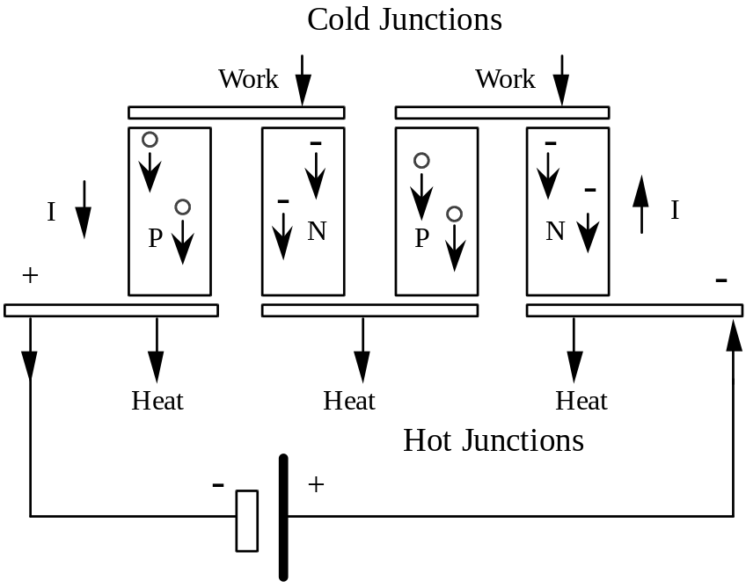
When current is passed through the unit, the upper series of junctions cools down while the lower series heats up. The N-type material conducts electricity by migrating electrons, but in P-type material, the conduction is by holes. If you picture the current passing through the semiconductor columns, you will see both the holes and electrons moving down toward the hot junction. The hole electron pairs have to be continuously created at the cold junction, and this requires work that is supplied in the form of heat. When they reach the bottom the hole electron pairs recombine to give back that work in the form of heat.
The Peltier Cooler Assembly device shown below (with appropriate signal conditioning and control) can cool devices like detectors (or even Pentium chips!) and hold the cold temperature steady to ±0.001 °C.
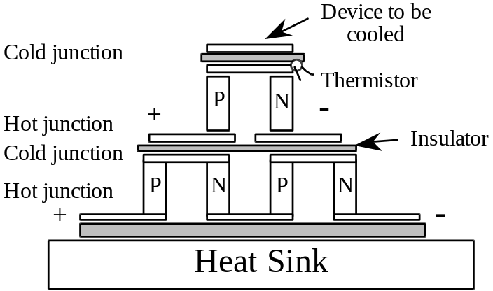
Electromagnetic Effect
(Electrodynamic)
Relative motion through a magnetic field will produce a voltage at the ends of a conductor. That is, if a conductor passes through a field or the field is moved across a conductor, the motion will produce a voltage at the ends of the conductor. This is Faraday’s law of induction. The motion produces a constant level of voltage across the conductor. The voltage e (V) induced in a wire of length L (m) moving at a velocity v (ms^{–1}) in a constant and homogeneous magnetic field of strength B (T or Wb per m²) is
e = (-)BLv

and the force f (N) exerted by a current i (A) flowing in a wire of length L immersed in a similar magnetic field is
f = BLi

Faraday’s law of induction for a rotational conductor states that the emf produced in a coil of N turns (OR a system of N conductors) due to a changing magnetic flux φ is
e = -N
(for explanation of the negative sign, refer to Lenz’s Law)

The effect can be used directly for the measurement of changing magnetic fields or of steady fields by rotating the coil at a known rate. Can also be used for measuring the velocity of a conductor moving in a magnetic field. In this situation, the change in flux is due to the motion being measured, e.g. a variable reluctance tachogenerator, where the output of the tachogenerator depends on the angular velocity of the toothed armature.
e = Bmω
where B is the flux amplitude, m is the number of teeth, and ω_{r} is the angular velocity.
This tachometer is the rotational equivalent of the moving coil velocity transducer. There are two main types, the d.c. tacho and the a.c. tacho. The d.c. tacho is essentially a d.c. generator with permanent magnet excitation. A coil rotates in the field of a magnet, many poles being used to produce a reasonably smooth output, and slip rings are required to obtain a d.c. voltage proportional to velocity. The device is very convenient and widely used in control systems where velocity feedback is required, but is unsatisfactory for precision measurement because of unavoidable ripple (due to the finite number of poles) and because of spikes due to the slip rings. The a.c. tacho is better in this respect. It consists of a rotating cylinder and two coils at right angles, one excited at constant frequency and voltage; the second coil detects a voltage proportional to the rate of rotation of the cylinder, owing to eddy current effects.

In another form, a magnetic sensor produces an output frequency, usually from an actuating gear, in direct proportion to rotational speed. The signal generated by the sensor in this mode is completely error-free and can be calculated for any given speed by the formula
frequency (f) = 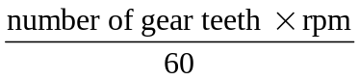
The frequency thus generated can be converted directly to rpm by means of a frequency counter or digital tachometer. Another method of speed measurement is to change the frequency into a proportional dc current.
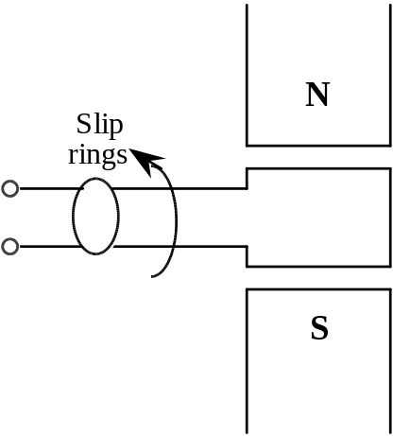
d.c. tachogenerator
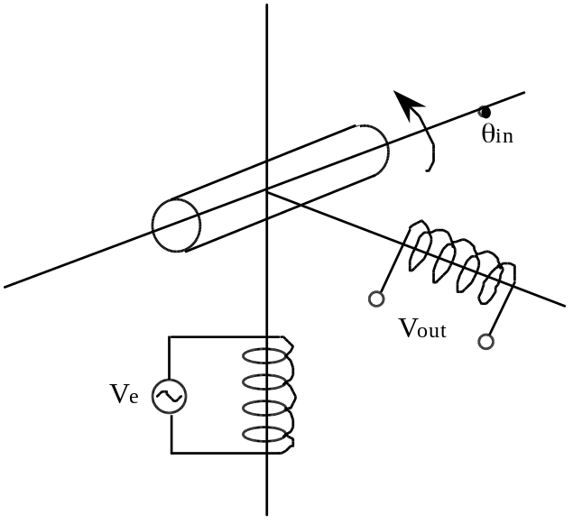
a.c. tachogenerator
When used directly for the measurement of changing or steady magnetic fields it is referred to as the electromagnetic effect, when used to measure the velocity of a moving conductor, it is the electrodynamic effect.
Piezo-Electric effect
This effect is exhibited by the appearance of a current or voltage when a force is applied to a suitable material. This effect does not occur in materials having a symmetrical charge distribution, since there is no reason for one surface to be favoured rather than another, but occurs only in crystals of certain types. The best-known naturally occurring material is quartz, but the effect can be produced in ferroelectric materials (especially lead zirconate (PZT)) by heating them in a strong electric field. The magnitude and direction of the effect depend upon the direction the crystal is cut with respect to its lattice.
Probably the most common example of piezoelectric material is the ceramic material in the stylus of a record player. As a record turns, the ceramic crystal flexes in the grooves, causing a voltage that represents the amount of flex. The voltage is amplified and sent to a loudspeaker.
In the actual transducer, one side is metallised, and the other subjected to the deformation. With this arrangement, we have effectively produced a capacitor (~4 pF quartz and 1600 pF for PZT), which produces some voltage when subjected to a pressure given by:
V= gtP

where g is a material dependent coefficient. Alternatively, we can look at the system as producing some charge q in response to a deformation of the thickness δt, where:
q = Kδt
K can be found in terms of g and the bulk modulus of the material
K = =

Piezo-electric devices are widely used for force and pressure measurement, but in practice their response to displacement does not extend to d.c., as the generated quantity is charge and not current, hence a constant pressure yields no permanent current. The maximum frequency which can be handled depends upon the mechanical resonance of the transducer and its mounting, and can be up to 1 MHz. They are also widely used for acceleration measurement, a small crystal supporting the spring, and detecting the relative displacement of the mass. The effect is reversible, and is referred to as electrostriction, in which an electric field is applied to the crystal, which then alters its shape. Evidently it is this effect which is responsible for the seemingly spurious noises which occasionally emanate from digital watches.
The wide use of piezo-electric transducers rises primarily from their high-frequency response, the fact that they are self-generating and also being small and rugged. Their disadvantages lie mainly in their high sensitivity to temperature changes and cross-accelerations, their high impedance outputs, and their long recovery time after being subjected to extreme shock.
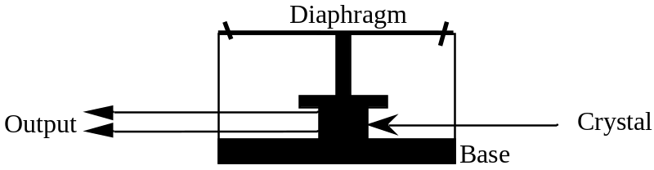

Photovoltaic Effect
Essentially these convert radiant energy into electrical energy, i.e. a “solar cell”. These are effectively ordinary diodes, with some electric field (junction field) at the p-n interface. This field is increased when the diode is reversed biased, and decreases allowing current flow when forward biased. The current relationship is given by
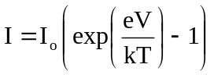

When light falls on a photoconductive material, electrons may be excited across the energy gap from the valance band to the conduction band. The excited electron, and the “deserted” hole are no longer tied together and are therefore free to move under the influence of the junction field, and therefore may flow in an external circuit. Under open-circuit conditions this will produce some voltage in the external circuit. Inherent in this situation is a large effective capacitance, which may limit the frequency response of the device.
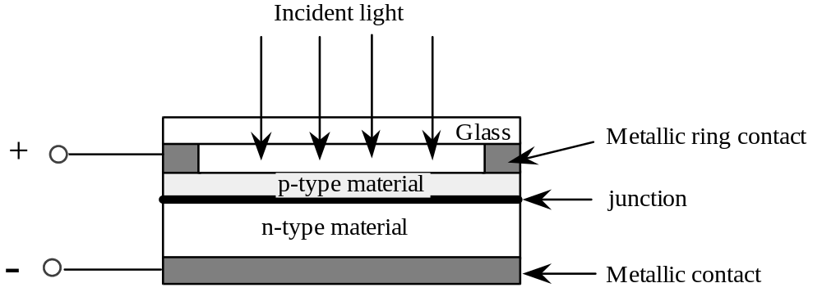

The basic silicon p-n junction photovoltaic cell consists of a thin layer of p-material deposited over a thicker layer of n-material, forming a p-n junction. The p-material is so thin as to be transparent to light; this light energy on the junction region creates electron-hole pairs. The electrons are pulled to the n-material, and the holes to the p-material. This action creates a potential difference between the two sides. When an external load is connected across the device, a current (which is a function of the light intensity) flows.
The responsivity is given by
r =

where the monochromatic radiation is of frequency ν, e is the electron charge, q some efficiency factor and h is Planck's constant. A typical value would be of the order of 0.1A/W at 1 µm (W/hν is the number of photons/second). Note that in order for this device to function, the liberated electron must be in the area of the junction, so the larger the area of the n-p type interface, the more efficient will be the “solar cell”. The actual dimensions can vary from 1 mm² to about 10 cm².
Cell Material Time constant Peak wavelength
Selenium (Se) 2 ms 0.57 µm
Germanium (Ge) 50 µs 0.8 µm
Silicon (Si) 20 µs 1.55 µm
Indium antimonide (InSb) 10 µs 6.8 µm
Indium arsenide (InAs) 1 µs 3.2 µm

These devices are not generally employed to detect light due to their low efficiency, and find most application in deriving an electrical output from incident solar energy. This may be particularly important when electronic devices need to be powered at some remote site, i.e. a trig station, or in space. Because of their low speed (refer above table), such transducers are also not suitable for detecting high speed events.
Other Optical Transducers
Do not to confuse a photovoltaic device with a photoconductive one. A photoconductive transducer is a two terminal device whose resistance varies inversely with the intensity of incident light. Common examples of these include cadmium sulfide (CdS) and cadmium selinide (CdSe) cells.
The photoconductive cell consists simply of a thin layer of material connected between two terminals. When the incident light on the device increases in intensity, the energy state of many electrons in the material also increases. This results in a larger number of free electrons and a consequent decrease in resistance. The speed of response of photoconductive cells tends to be slower than that of other types of photosensitive detectors. A phototransistor (or photodiode) tends to be used in applications where high frequency response is desired.
As we have already discussed, electromagnetic radiation such as light can alter the p-n junction characteristics of a semiconductor device, so both diodes and transistors can be made sensitive to light. The fact that the incident light is now on the p-n junction as opposed to some photosensitive crystal, is really the only difference from the photoconductive devices, however the response times are much faster. A phototransistor results from the addition of a second p-n junction. They are more sensitive than photodiodes as they have typically a 100 to 1000 times higher internal gain.
Nuclear Sensors
One range of devices not so far considered are those which depend upon the disintegration of an atomic nucleus. An atomic nucleus can emit either alpha (helium nuclei), beta (electrons) or gamma (EM) radiation. One form of a nuclear sensing setup would contain some radioactive material that acts as the emitter (or transmitter) and a receiver that counts (or indicates) the number of particles received. In between the emitter and detector is some substance that absorbs radiation. Moisture can be detected in continuous rolls of paper by this method. The more moisture present, the more the radiation is attenuated. Other examples include the injection of radioactive dyes into patients, and also some forms of smoke detectors.
A particular smoke detector might consist of a radioactive source e.g. Americium 241, which makes the air conductive by means of alpha particles emitted from the source. The alpha particles ionize the air molecules into positive ions and negative electrons. When a voltage is applied across the ionization chamber a small electrical current is caused to flow. When the products of combustion enter the chamber they too are ionized but due to their relatively large size, they move more slowly, thereby reducing current flow and thus trigger the alarm. Note that in this particular configuration there is no nuclear particle counter.
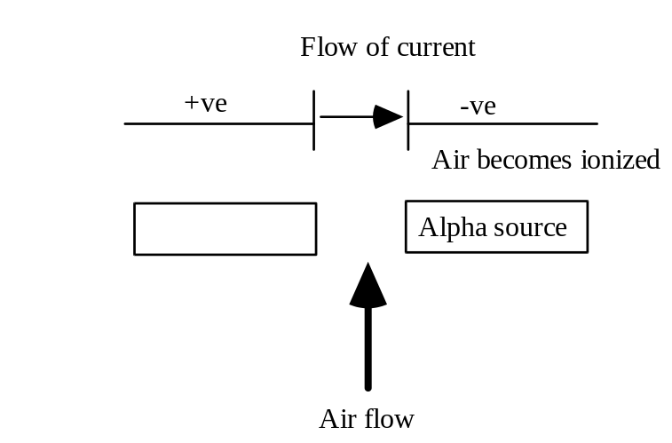
Signal Conditioning Elements
In a microprocessor-controlled system, the analogue signal is useless until it is converted to a form that is acceptable to the computer. For example, a transducer that outputs a microvolt signal must be amplified before it may be converted into a digital signal. This process is referred to as signal conditioning. Other signal conditioning processes include dividing, filtering, etc.
Once again we have the distinction between passive and active signal conditioning. The passive signal conditioners are those that are not modified by electronics. That is, they are not modulated, amplified, integrated and so on. They utilise discrete fixed components such as the resistor, capacitor and inductor. Active signal conditioners are those that modify the signals with the use of electronic devices such as discrete solid-state circuits and integrated circuits.
Voltage Dividers
In its simplest form, a voltage divider consists of two resistors connected in series to some voltage supply. The voltage will drop over each resistor in proportion to the value of the resistance. If the two resistors are equal, then the voltage drop will be the same across each of them.
In general, however, the relationship is given by
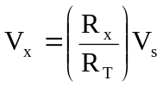
where V_{x} is the voltage across a resistor (or combination of resistors), R_{x} is the resistance across which the voltage is to be determined, and R_{T} is the total series resistance.
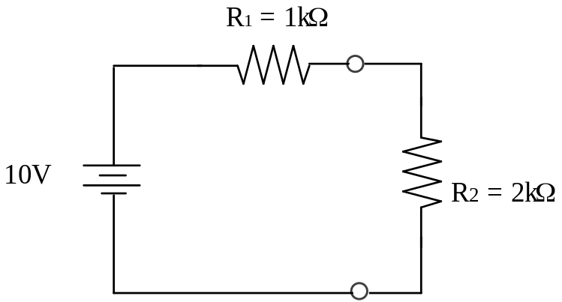
If we assume that R₂ is the load (or test) resistor, then the voltage across it is given by
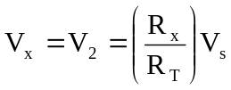
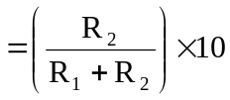
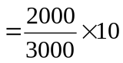
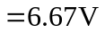
More often a potentiometer is used as a voltage divider. In this case, the potentiometer is effectively two resistors, the values of which are set by the position of the wiper. As the wiper is moved, one resistance increases, while the other decreases. We have explored this to some degree in the section dealing with resistive displacement transducers.
Voltage dividers have a large number of applications, ranging from the volume control in radios, to a fluid level indicator in a petrol tank, and also for setting the d.c. operating voltage (bias) in transistor amplifiers.
A complication arises when there is some resistive load placed on our voltage divider.
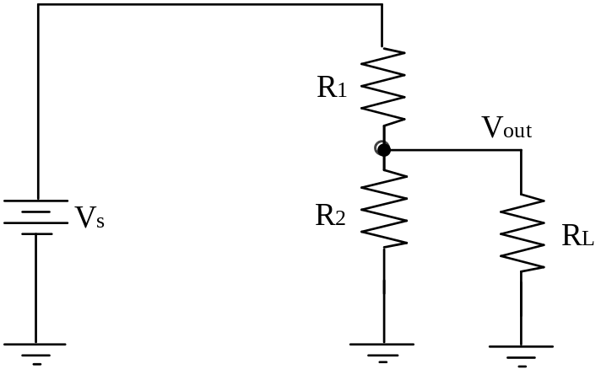
When a load resistor R_{L} is connected from the output to ground as above, the output voltage is reduced by an amount that depends on the value of R_{L}. The load resistor is in parallel with R₂, reducing the resistance from point A to ground and, as a result, also reducing the voltage across the parallel combination. This is one effect of loading a voltage divider. Another effect of a loaded condition is that more current is drawn from the source because the total resistance of the circuit is reduced.
The larger R_{L} is (compared to R₂), the less the output voltage is reduced from its unloaded value. The reason is that when two resistors are connected in parallel and one of the resistors is much greater than the other, the total resistance is close to the value of the smaller resistance.

Deflection Bridges
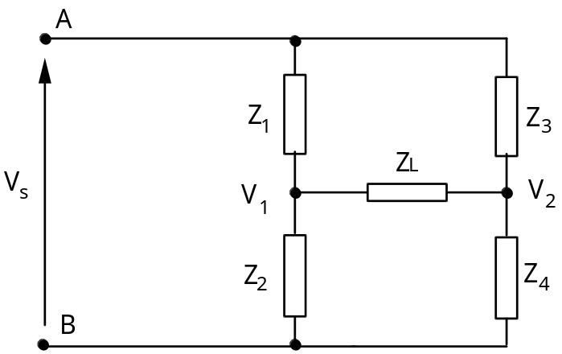
Supply voltage V_{in} between terminals A and B; V₁ and V₂ are measured relative to B. Z_{n} are any general (linear) impedance.
This is the general form of a deflection bridge where Z_{n} may be any (complex) impedance. You have probably dealt with this form of bridge when all the impedances are simple resistances. In this case we have the common Wheatstone Bridge.
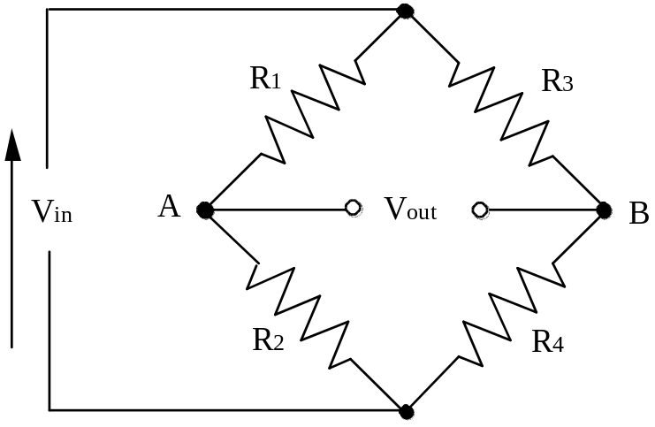
When a load resistor is connected to the output terminals of a Wheatstone Bridge (labelled Vabove), as would be necessary if we wanted to analyse the effects of applying a galvanometer to these terminals, then the circuit becomes very difficult to analyse. Try to identify which resistances are in series, and which are in parallel in the arrangement following.
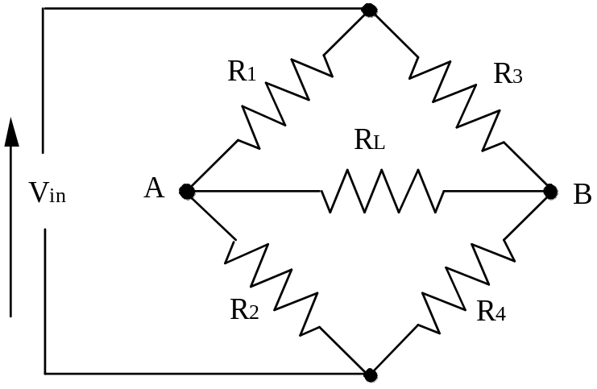
Using Thevenin’s theorem, we can simplify the bridge circuit to an equivalent circuit viewed from the load resistor, as is shown step by step below.
Initially remove R_{L} (and as we are typically dealing with d.c. supply voltages, replace V_{in} with a battery symbol (V_{s}). We need to be able to evaluate V_{TH}.
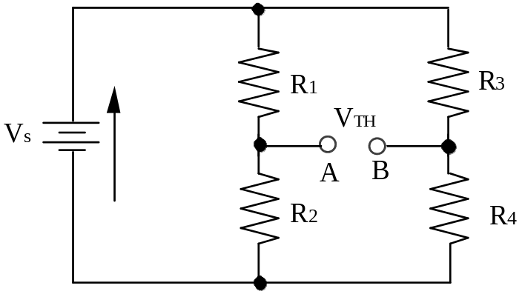
It can be seen that
V= V- V= 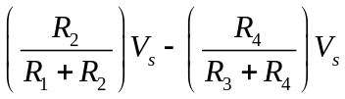
Next step is to replace V_{s} with a short
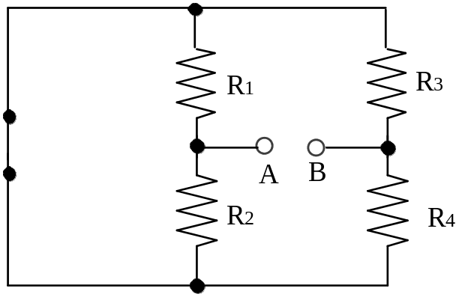
which we can redraw to find R_{TH}
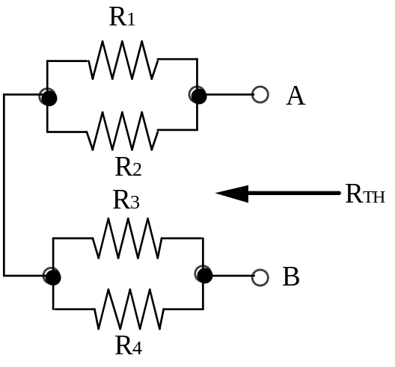
It is now obvious that
R_{TH} = R₁ || R₂ + R₃ || R₄
So our equivalent circuit with R_{L} reconnected is
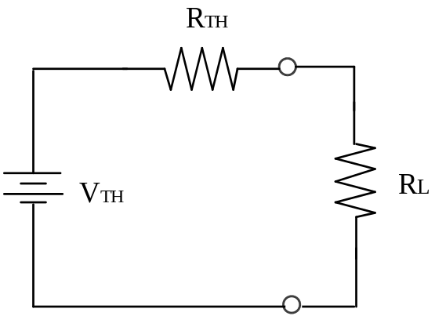

The current through the load resistor is given by:
I= and V= .
V_{L} is the measured output voltage. If V= 0.9 V,
0.9 R= 0.1 R, i.e. R= 9 R.
If R= 25 R, V=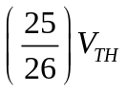,
V_{L} is within 5% of V_{TH}.
i.e. ideally we want R_{L} as large as possible (i.e. high load impedance) and R_{TH} as low as possible (i.e. near zero bridge impedance)
Resistive Deflection Bridge
The primary measurement circuit used in instrumentation and specifically with strain gauges is the resistance bridge. The prominent type is the Wheatstone bridge, which can be used to determine the resistance of any unknown resistance. This, as previously mentioned, is exactly the same as the general impedance bridge, but all impedances are replaced by simple resistors. The Thevenin equivalent circuit has been previously evaluated for this form of bridge above (but note, that an analogous solution exists for the more complex general impedances).
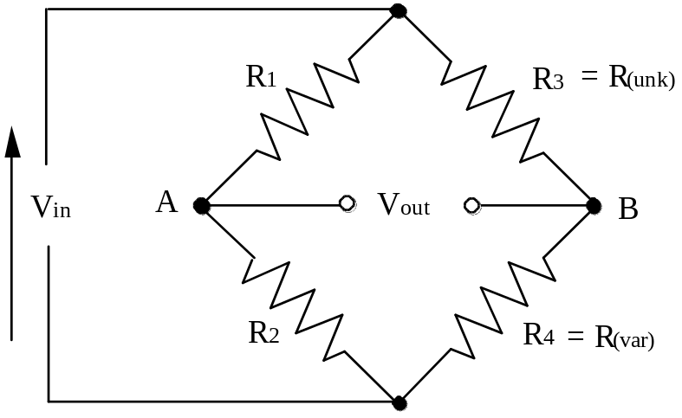
The basic Wheatstone bridge is as shown. R₁ and R₂ comprise a voltage divider from the power source. R_{unk} (the unknown resistance) and R_{var} (the variable calibrated resistance) represent the second voltage divider from the power source. R₁, R₂ and R_{var} are all very accurate components whose values are known.
A precision galvanometer is placed between points A and B. When power is applied to the circuit, the galvanometer will indicate current flow. Resistor R_{var} is then varied until the galvanometer shows no current flow, indicating that the bridge is balanced. When balanced :
=
The current component may be removed as the current must be equal in each component of the same leg, yielding
=
A bridge is used for 3 reasons: as a circuit for determining an unknown resistance, as a null detector, and as a circuit to measure the difference between two voltages or currents.
An unknown resistance (or a small resistance change) can be determined quite accurately. From the previous equation we can see that:
R=
As a null detector, the output of the bridge would be null (V_{out} = 0 V) when the bridge was balanced. As a detector of voltage the input V_{in} is placed between opposite terminals, while the output V_{out} is taken from a second set of terminals. In essence, the bridge output is measuring the difference voltage between the leg pairs. The first leg is a series voltage divider looking at the voltage across R₂, i.e. V₁.
V=
The second leg is a series voltage divider looking at the voltage across resistor R₄ (V₂)
V=
V_{out} is the voltage difference between the two series legs.
V= -
or
V= 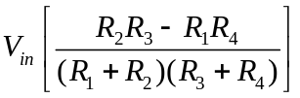
= 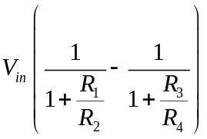
The bridge allows for the detection and measurement of small resistance changes. A change from bridge balance may easily be monitored, as the output V_{out} changes as any adjacent leg resistance changes. The change is represented by a difference of potential between the parallel legs.
In transducer arrangements, the ratio of fixed resistances such as R₁ /R₂ are fixed at a constant ratio K. If R₃ is unknown and R₄ is an accurate variable resistance, the size of R₃ can be determined by adjusting R₄ until a null is achieved. From the above equation, it is immediately obvious that the balance condition
=
will result in a null output.
Now for notational convenience, let R₃ (our unknown resistance based upon the measured) be represented by R_{m}. R_{m1} is the maximum value for R_{m} and R₄ is varied so that V_{o} = 0 when R_{m} = R_{m1}.
R= . R ; Rchosen to give V= 0
at R= R.
Thus swapping signs of the two voltage legs (with no loss of generality):
= -
or letting r = and x =
v = –
= –
When x = 1, R= Rand the bridge is balanced.
For a strain gauge, ΔR = RGε,and since R>> ΔR, x \S\up2(~)1; for maximum sensitivity, we require 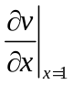to be a maximum; this occurs when r = 1, i.e. 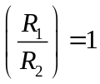
Thus, for balance and maximum sensitivity,
R= Rand R= R, and for single strain gauge bridge,
R= R= R= R= R, unstrained value of resistance.

Four element strain gauges are used in such applications as pressure-sensitive diaphragms and cantilevers. Usually, 2 gauges are in tension and two in compression. The output voltage is given by:
V= VGε, where ε is the strain.
For a platinum resistance sensor,
R= R₀(1 + αT)
and usually Rchanges from Rto 2R, i.e. x \S\up2(~)1 to 2, where x = .
Now is constant over a limited range (Ris linear with T) and thus there needs to be a linear relationship between Vand Rfor Vto be linear with T. This means using r \S\up2(~)100, and since x \S\up2(~)1 to 2, r >> x,
and v ≈ ,
or V= V_{s}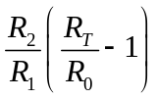
= V αT, i.e. linear with T.
The non-linear relationship between small r and v is used to cancel out (to some extent) the non-linear relationship between thermistor resistance and temperature.
The purpose behind all of this is to find justification for the values of the constant resistors Rand R, and to determine the range for the variable resistor in order to give maximum sensitivity. The constant resistors can determine the linearity of the system.
A Wheatstone bridge with a strain gauge in one arm is called a quarter-bridge configuration. Often a dummy gauge is used in the same arm that does not experience the strain; it is included for temperature compensation. To determine the strain, the output voltage with no strain is observed; the bridge can be balanced (zeroed) at this point by adjusting one of the bridge resistors. The gauge is then subject to strain, and the output voltage is observed again. The strain is found by the equation:
ε =
V_{r} is a dimensionless number that represents the difference in the ratios of the output to input voltage between the strained and unstrained condition:
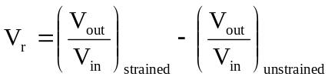
where V_{out} = output voltage from the unloaded bridge, V
V_{in} = excitation voltage V

The above expression for strain takes into account the nonlinearity of the bridge. This error is very minor at the low levels normally encountered in experimental stress analysis work. If the bridge is initially balanced (V_{out}, unstrained = 0 V) and we ignore the very minor nonlinearity of the bridge near balance, this strain equation reduces to
ε =
When two active gauges are used, the configuration is called a half-bridge. A half-bridge configuration produces increased sensitivity over a quarter-bridge arrangement and is best applied to measuring bending beams. For bending measurements, the two gauges are installed so that one is in tension and the other is in compression by installing one directly on top of the other and on opposite sides of the beam. They are connected in adjacent arms of the Wheatstone bridges. This arrangement causes temperature effects, which change the resistance of both gauges in the same way, to be cancelled because they are in adjacent arms of the bridge.
For axial strain measurements, the connection of the active strain gauges is to the opposite diagonals, causing bending effects to be cancelled and axial strain to be additive. In this arrangement, temperature effects that change the resistances are additive, since the gauges are installed in opposite diagonals. A common procedure is to include the use of compensating (dummy) gauges for nullifying temperature effects in the remaining arms. Compensating gauges can be mounted on a small unstrained block of the same material as the specimen or they can be mounted in such a manner that they do not experience strain.
The chief advantage of a half-bridge over a quarter-bridge is an increase in the sensitivity by a factor of 2. If we ignore the minor nonlinearity error for the bridge, the strain for a half-bridge arrangement can be found from the equation
ε =
A full-bridge configuration uses active gauges in all four arms. Two strain gauges in opposite diagonals are in tension and the other two are in compression. Temperature compensation can still be included by placing compensating elements in the excitation lines, but we will not be concerned with that in this course. Again ignoring the minor nonlinearity error, the strain for a full-bridge arrangement with four equal strain gauges can be found from the equation
ε =
Load cells are generally constructed with 350 Ω strain gauges mounted in a full-bridge arrangement. Notice that the resistance measured from excitation leads to output leads will also measure a nominal 350 Ω in the unstrained condition. When the strain gauges are mounted in a load cell in the full-bridge configuration, the fullscale output of the load cell is normally designated to be 1, 2, or 3 mV of signal per volt of excitation.
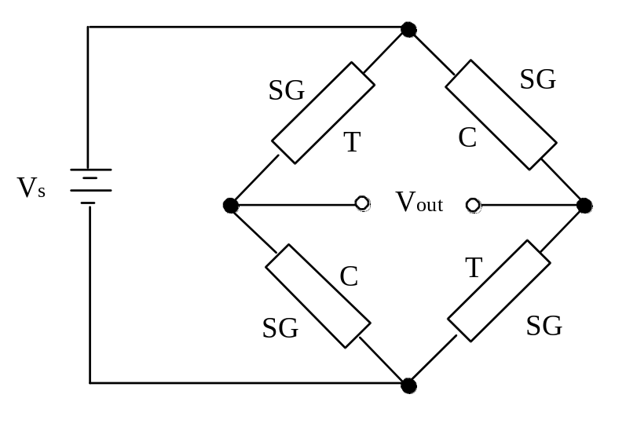

Reactive Deflection Bridge
Reactive deflection bridges use reactances, usually in the push-pull mode. Two arms are resistive and two arms reactive.

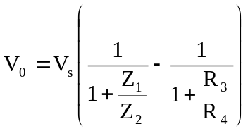,
If our impedance element is a capacitor (as opposed to an inductor) then
Z =
i.e. Z₁ would be an unknown capacitance, whilst Z₂ would be a variable capacitor, which would be set to null the bridge output
In general, Z₂ will not be linear with the measurand. In the example of using capacitance, we know that
C =
and as capacitance is not linear with variation in x, neither is the resultant impedance. This non-linearity can be eliminated using a push-pull arrangement, i.e. have both Z₁ and Z₂ as transducer elements, with the capacitance of one increasing with x, the capacitance of the other decreasing with x.
C= , C=
This gives
V∝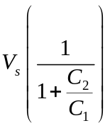
V∝ 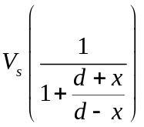
= 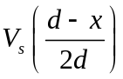
i.e. V_{o} ∝ x, so the system is now linear!
Note that our above analysis assumes an ideal capacitance (i.e. the capacitor does not have some inherent resistance). Also, obviously, we can no longer have a d.c. excitation (V_{s})!

The Operational Amplifier
Circuit Theory
These sections discuss the process of converting an analogue signal into digital. We will first consider the properties of the op-amp (OA), which not only is a basic building block of modern low frequency analogue electronics, but is also an integral part of A/D circuitry. The basic characteristic of an OA is that of a voltage difference amplifier with a very high gain (or amplification). The schematic symbol for an OA is shown below:
V_{cc} (12 to 15 V typ.)
+
-
I₊
I₋
V₊
V₋
V_{o}
-V_{cc} (-12 to –15 V typ.)
Non-inverting terminal
Inverting terminal

Usually the OA runs off bipolar supply rails ±V_{cc} of typically ± 12-15 V, but these connections are normally omitted from diagrams – they are essential for actually building the circuit however!
An ideal OA is characterised by:
- Infinite input resistance at the input terminal, so that the currents I₊ and I₋ are zero.
- A very high voltage gain A (>200,000) with an output voltage given by:
V_{out} = A (V₊ - V₋) (1)
In practical terms this means that the voltage difference at the input terminals is low enough to assume it is essentially zero.
- Zero output resistance.
These three basic characteristics can be used to model the (ideal) behaviour of most OA circuits.
Applications of the Operational Amplifier
The Voltage Follower (or Unity Gain Buffer)
+
-
V_{in}
V_{o}
Op-amp connections for the voltage follower

This circuit is used as an impedance buffer when we drive a low resistance load from a high resistance source – it overcomes the problem of potential drop across the internal resistance of the source for large output currents.
From equation (1) we have that:
V_{out} = A (V₊ - V₋) and V₊ = V_{in}, V₋ = V_{out}
⇒ V_{out} = A (V_{in} – V_{out})
∴ V_{out} = V_{in}/(1 + A⁻¹) ≈ V_{in} if A → ∞ (2)
+
-
R_{L}
I=0

The Voltage Follower with Gain (Non-inverting Amplifier)
The basic voltage follower may be modified by taking the feedback point from the centre tap of a potential divider connected to the output:
+
-
V_{in}
V_{o}
Op-amp circuit configuration for a voltage follower with gain
R₂
R₁

Using the three OA characteristics the circuit can be analysed as follows:
V_{out} = A(V_{in} - βV_{out}) where β = R₁ / (R₁+ R₂)
∴ V_{out} = AV_{in} - AβV_{out}
∴ V_{out}(1 + Aβ) = AV_{in}
∴ V_{out} = AV_{in} / (1 + Aβ) ≅ V_{in} / β for βA >> 1
∴ V_{out} = V_{in} (R₁ + R₂) / R₁ (3)
Current to Voltage Converter
-
+
V_{in}
V_{o}
Op-amp circuit configuration for a current to voltage converter
R_{f}
I
I_{in}

Since the (ideal) op-amp has infinite input resistance, we must have: I = I_{in} (a)
Current I flows due to a potential difference: V – V_{out} = I R_{f} (b)
And from the OA equation we have: V_{out} = A(0 - V₋) (c)
Substitute (c) into (b) and rearrange: ∴ V_{out} = -A I R_{f} / (A+1) ≅ -I_{in} R_{f} for A>>1 (4)
and V- = V_{out} / A ≈ 0 for A>>1 = ‘Virtual earth’
The concept of a ‘virtual earth’ is very useful in circuit analysis. What it means is that the potential at the non-inverting terminal is not actually zero (otherwise V_{out} would also be zero!), but is very close to zero, perhaps a few hundred μV. Therefore, for circuit analysis purposes it can be regarded to be ‘virtually’ at ground potential.
The current to voltage converter is widely used in current-input digital to analogue converters (DAC’s) for producing a voltage output. The current I could come from a single source, or from multiple sources, in which case the output voltage is proportional to the sum of the input currents.
The Inverting Voltage Amplifier
The following modification to the I – V converter results in an inverting voltage amplifier:
-
+
V_{in}
V_{o}
Op-amp circuit configuration for an inverting voltage amplifier
R_{f}
I
I_{in}
R_{in}
Virtual earth

Note that the concept of a virtual earth results in the voltage input + resistor combination being a simple current source. The analysis follows from the current to voltage converter:
I_{in} = V_{in} / R_{in}
I_{in} = I
and, -V_{out} = I R_{f}
so, V_{out} = -V_{in} (R_{f} / R_{in}) (the output is negative for a positive input) (5)
Voltage Summer
-
+
V₁
V_{o}
Op-amp circuit configuration for a voltage summer (with optional input inverter for subtraction)
R_{f}
I
I_{in}
R₁
V₂
R₂
-
+
R
R

The above arrangement will sum the input voltages if the resistors are chosen such that:
R₁ = R₂ = R_{f}

If an inverting amplifier of gain –1 precedes one input, then subtraction of the input voltages will result. This is often used to generate a bipolar output from a unipolar design DAC.

DAC
I_{DAC}
R_{off}
-V_{off}
R_{f}
V_{out}=((V_{off}/R_{off}) – I_{DAC})R_{f}
-
+

Integrator
-
+
V_{in}
V_{o}
Op-amp circuit configuration for an integrator
C
I
I
R
+Q
-Q

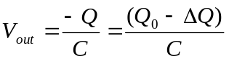 with Qo = Q(t = 0)
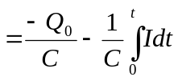 with I = V_{in} / R
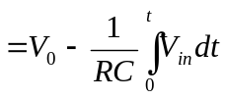 with V_{o} = Q₀ / C = V_{o}(t = 0) (6)
V_{out}
t
For a constant V_{in} = V₁, V_{out} = V₀ - (V₁/RC)t

Hence the output is the (negative) integral of the input. This configuration is used in integrating type analogue to digital converters.
Non-ideal Characteristics of Op-Amps
Offset Voltage
The output of a real OA will always contain an offset term:
V_{out} = A(V₊ - V₋) + V_{off} = A[(V₊ - V₋) + ΔV_{off}] with ΔV_{off} = V_{off} / A (7)
Where ΔV_{off} is the ‘offset voltage’ of the OA, typically a few mV, referred to the input. The offset voltage of the OA means that you have to apply -ΔV_{off} to the inputs to get zero volts at the outputs. The smaller the offset voltage the better. It is normally possible to add a trimming circuit to the OA to cancel out the voltage offset, so that it is the temperature coefficient of the offset that is normally more important than the actual offset voltage itself.
Saturation
The OA has a linear gain or amplification as given by equation (1) only when the output stays within the limitations of the power supply that is powering the OA. Usually this means that the output can be no more than the positive rail minus two diode drops (2 × 0.7 V). All the formulae derived above assume that the OA stays within its linear range of operation. Beyond these limits the OA is said to be saturated – the output no longer changes with a change in input (well not in a very predictable way anyway!).
~V_{cc} – 2V_{d}
~ -(V_{cc} - 2V_{d})
V_{out}
Saturated

(V_{out} – V_{in})

Bandwidth and Gain
The analyses used previously all assume that the gain A >> 1. However, while the gain of most op-amps is around 200,000 at DC, at a frequency of a few Hz it starts to decrease until at some frequency, called the ‘unity gain bandwidth’, it drops to A = 1. Clearly the formulae derived previously no longer hold for frequencies near the unity gain bandwidth frequency, since A ~ 1 here and most circuits rely on Aβ >>1. The higher the unity gain bandwidth the better suited the OA is for high-speed applications, with the possible risk that it is less stable than slower op-amps.

log(A)
slope =-1

unity gain bandwidth

log(f)
1
A typical gain-frequency characteristic for an op-amp

Input Currents
Any real op-amp necessarily has non-zero input currents. In the case of a bipolar op-amp, these are the base currents of the input transistors, while in the case of JFET or MOSFET op-amps they are leakage currents. These currents flowing through the circuit resistances create potential drops that are amplified in the same way as the deliberately applied signals. If the two currents (for the non-inverting and inverting inputs) are equal then it is possible to balance their effects by matching resistance values such that their input bias current offsets are equal. JFET and MOSFET input op-amps have much lower bias currents than bipolar types.
Slew Rates
There is an upper limit to how fast an OA output can change that is determined by the internal design of the op-amp. A sine wave A.sin(ωt) has a maximum slope of ωA, so an amplifier that works well at low slew rates may not be able to keep up with faster changing inputs.
‘Slew rate’ = 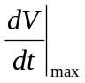 (8)
The Comparator
A comparator is a special-purpose op-amp that is used to compare two analogue voltages and deliver a digital output of:
0 if V₁ > V₂
1 if V₁ < V₂ (9)
It is widely used in ADC circuits for comparing an unknown input voltage with a fixed reference voltage. The transfer characteristic, together with a schematic diagram is shown below. The internal design is that of a fast op-amp driving an open-collector output transistor. This permits the use of a range of digital logic levels - it is the user’s responsibility to provide the external load resistor R_{c}.

V_{ref}
LOW
HIGH
V_{out}
V+
V_{in} = V₊
V_{ref} = V₋
V_{cc}
-V_{cc}
R_{c}
V_{cc}
V_{out}
+
-
+
-

One problem with using a comparator in its basic form is that of multiple transitions. If one input is fixed while the other has superimposed noise and is slowly rising, it is possible that a series of transitions will occur rather than a single one. If the comparator were driving a circuit such as a counter, this would result in an incorrect result.
V_{ref}
V_{in}
V_{out}

The solution is to use the comparator with positive feedback as shown in the circuit below. The effect of the feedback is to introduce hysteresis in the transfer characteristic, so that once the transition occurs the input has to fall by more than the hysteresis width before a reverse output transition will occur.
+
-
V_{in}
V_{out}
A comparator with positive feedback
R_{f}
R_{in}
R_{c}
V_{cc}
V_{ref}

Analysis:
- Output LO (~0): 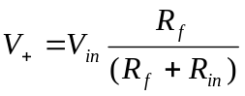 which must be > V_{ref} for switching (10)
i.e. we must have 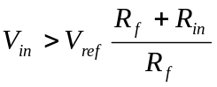 which is > V_{ref}.
- Output HIGH (~V_{cc})
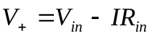 and 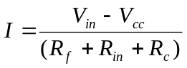
so 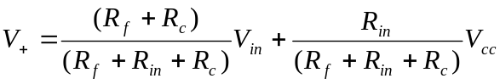
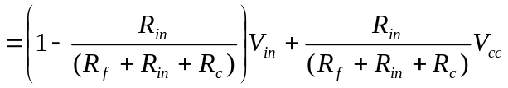
which must be < V_{ref} for switching to occur
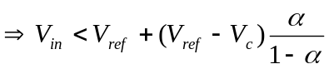 where 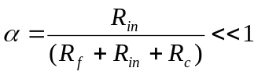 usually (11)
The quantity on the right of the above equation that involves α is negative, therefore the switching point, when approached from above, is less than the reference voltage. Hence we have hysteresis in the switching characteristic; the switching point depends on the direction from which it was approached. The width of the switching interval is approximately αV_{cc}, which can be derived from equations (10) and (11). The modified transfer characteristic will thus have the form:
V_{ref}
LOW
HIGH
V_{out}
V_{in}
hysteresis width

The advantage of this arrangement is that any noise superimposed on a signal must be of magnitude greater than αV_{cc} before it will cause transient switching problems. On the other hand the accuracy of the comparison with the reference voltage is reduced since the switching points are different depending on the ‘direction’ from which the input voltage approaches the reference voltage.
More exactly, any noise superimposed on the signal must be greater than:
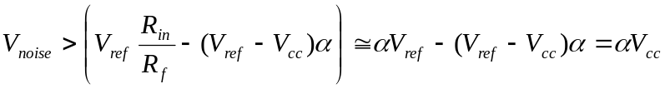 peak-to-peak
before it will cause multiple transitions. Typically, α~10⁻³.
Filters

Next to amplifiers, filters are probably the most common analogue circuit element. There are two general classes of filters: passive, which consist of the passive components R, L, and C; and active, which contain active elements such as amplifiers as well as the usual passive components. The availability of inexpensive high-quality op amps has revolutionized active filter design. Op amp active filters can amplify and filter the incoming signal, and they completely eliminate the need to use a real inductor with all its attendant problems of size, weight, strong magnetic fields, tendency to vibrate, expense, fragility and so on. Also, both the tuning and the Q of an active op amp filter can be varied by changing a resistance, in contrast to passive filters. At frequencies below 100 Hz, passive filters are impractical because of the large inductors and capacitors required, whereas active filters are practical. The only application where passive filters are superior is high-frequency filtering above ~ 500 kHz. Finally, an op amp active filter can be made with a very high input impedance and a very low output impedance, so impedance matching problems in the sources and loads are almost eliminated. Thus it is quite simple to cascade active filters in series.
Passive
Series circuits
Filters are frequency selective circuits that permit signals of certain frequencies to pass from the input to the output while blocking all others. That is, all frequencies but the selected ones are "filtered out". Series RC circuits exhibit a frequency-selective characteristic and therefore act as simple passive filters. There are two main types of such filters, Low Pass and High Pass.
Low Pass RC Filter
An RC Low Pass filter is shown below.
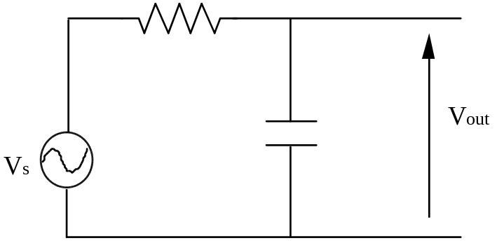
which has the transfer function (gain versus frequency) of
A =
|A| =
The frequency at which the capacitive reactance equals the resistance in a low pass or high pass RC filter is called the cutoff frequency f_{c} (or break frequency ω_{b}). In filters, the cutoff frequency is the final point at which the filter response drops to 3 dB (or 0.707) of its peak value on the way out of the passband. It is the "half power" level. The break frequency is given by
ω= or f=
The exact dependence of the output voltage with frequency is given mathematically above, but essentially the capacitive reactance decreases as frequency increases, thus dropping less voltage across the capacitor (that is to say that the output voltage drops as frequency increases). A plot of V_{out} versus frequency is known as the response curve, and the response curve for a low pass filter is shown below.
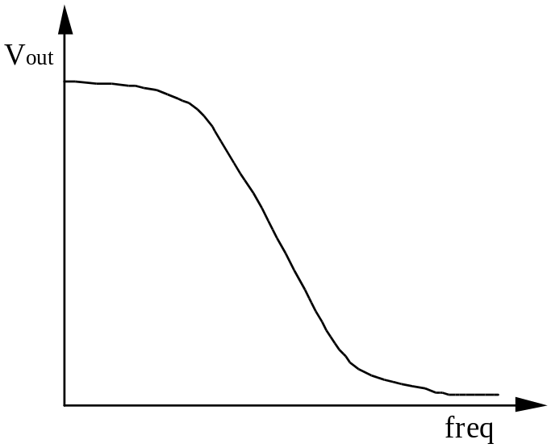
High Pass RC Filter
The high pass filter swaps the position of the capacitor and resistor. Again, the capacitive reactance decreases as frequency increases. As this reactance decreases, there is less of a voltage drop across the capacitor, which results in an increased current flow, and hence an increased voltage drop over the resistor. In other words, as frequency increases V_{out} increases. The appropriate circuit and response curve is shown below.
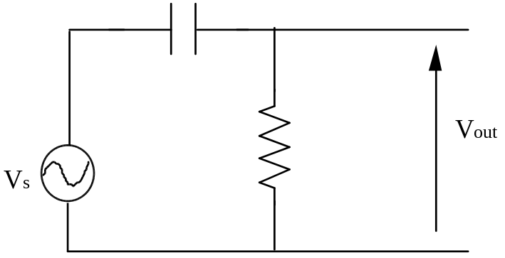
The transfer function is given by:
A =
or
|A| =
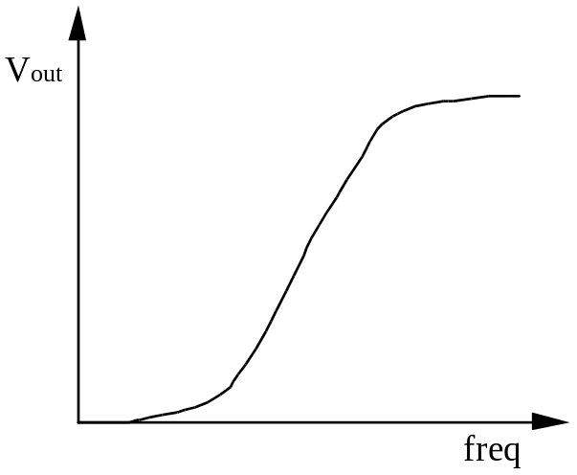
The cutoff frequency f_{c} is given by:
f=
alternatively (ω= as previous)
At the cutoff frequency V_{out} = 70.7% of its maximum value. f_{c} is considered the limit of a filter's performance. For example in a high pass filter, all frequencies above the f_{c} are considered to be passed, all others rejected. The range of frequencies considered to be passed by a filter is called the bandwidth.
Second-Order RC Filters
The order of a filter governs the rate of falloff of the magnitude response with frequency. For example, a second-order low-pass filter falls off as the square of frequency for high frequencies, or at a 40 dB/decade rate (12 dB/octave). The number of energy-storage capacitors (or inductors) in most filters determines their order. A fifth-order filter usually takes five capacitors and so on.
If two passive low-pass RC filters are cascaded in series, the gain above the cutoff frequency falls off at a rate of 40 dB/decade, but the "knee" is quite rounded. To prevent the two passive RC filters from affecting one another, there must be some buffer circuit between them (with a high input and low output impedance). The overall gain of the two low-pass RC filters interconnected with the buffer is simply the product of the gain of the individual filters
A = 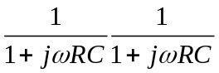= 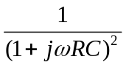
RL Low-Pass and High-Pass Filters
It is also possible to have an RL low pass and high pass filter. An example of a high pass filter is shown below. The low pass filter is equivalent, with the resistor and inductor swapped.
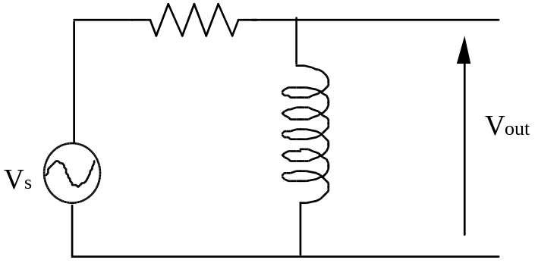
This is an analogous situation to the RC circuits discussed above. However in this case, the inductive reactance increases as frequency increases. Therefore when the output voltage is taken across the resistor we have a low-pass filter (current decreases), and when V_{out} is taken across the inductor a high pass filter results. The cutoff frequency is defined as f= , where once again V= 70.7% of its maximum value. It is unusual to see RL high or low pass filters as the inductors are bulky, expensive and tend to not perform as well (less ideal) as capacitors.
RCL Second-Order Filters
A second-order low-pass passive filter can be constructed from an RCL circuit. The output is taken across the capacitor, and intuitively you would expect the high frequencies to be attenuated as the capacitor will tend to act like a short and the inductor will have a high impedance at high frequencies.
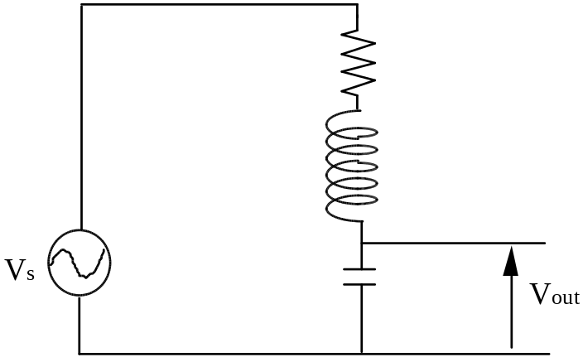
The transfer function is given by:
A =
=
The passive LRC low-pass second-order filters differ in one important respect from the buffer-cascaded RC low-pass filter. The shape of the transfer function of the LRC filter depends strongly on the magnitude of R, in other words, on the Q or the damping factor. For zero R, Q is infinite and the gain will be infinite at the resonant frequency (1/). As R is increased, the gain at resonance decreases, and there is a certain value of R above which there is no relative maximum in the |A|-versus-frequency curve.
As well as high and low pass filters, an RCL circuit can be constructed to form a configuration known as a bandpass filter.
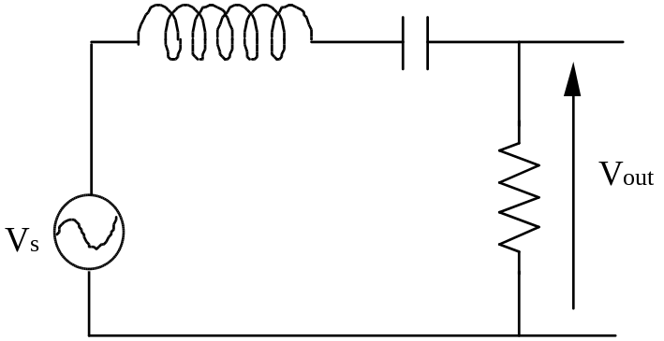
Such a circuit has a resonant frequency when the capacitive reactance equals the inductive reactance X_{L} = X_{c} . This occurs when
2πfL =
f=
A bandpass filter allows signals at the resonant frequency and at frequencies within a certain band extending above and below the resonant value to pass from input to output without a significant reduction in amplitude. Signals outside this "pass band" are reduced in amplitude and are considered to be rejected.
The impedance of a circuit is a minimum at resonance, and has increasingly higher values on each side. At low frequencies, impedance increases, therefore less current flows. As the frequency increases towards resonance, the impedance decreases allowing more current to flow with a corresponding increase in the output voltage (taken across the resistor). At the resonant frequency (f_{r}) the impedance is very low (effectively being solely due to the resistance in the coil windings), and hence the maximum current is flowing, and V_{out} also reaches its maximum value. As the frequency increases past the resonance, the impedance again begins to increase, lowering the current and output voltage.
The bandwidth of a bandpass filter is the range of frequencies for which the current (or V_{out}) is greater than or equal to 70% of its maximum value at the resonance frequency. This bandwidth is defined as
BW = f- f
f= lower cutoff frequency
f= higher cutoff frequency
fand fare also called the 3dB frequencies, the band frequencies and the power frequencies. The response curve for a bandpass filter is shown below.
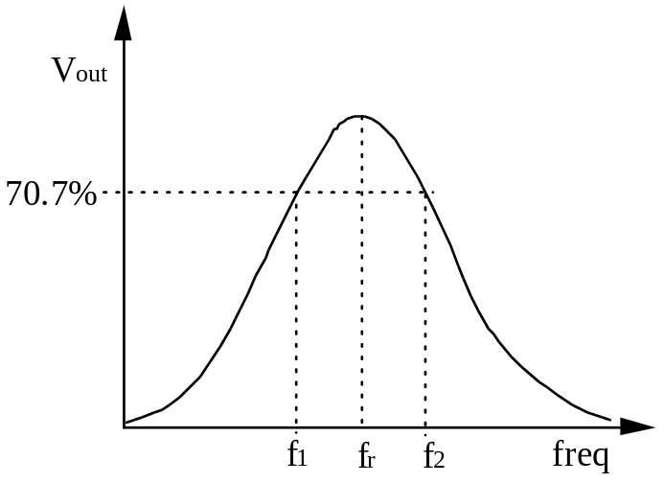
This response curve is also called the selectivity curve. Selectivity defines how well a resonant circuit responds to a certain frequency and discriminates against all others. The narrower the bandwidth, the greater the selectivity. The finite slope of the response curve implies that some unwanted frequencies (outside the bandwidth) are not completely eliminated, although their magnitudes may be greatly reduced.
The Quality factor Q of a resonant circuit is defined as the ratio of the reactive power in the inductor to the true power in the winding resistance in the coil or the resistance in series with the coil.
Q = = =
In a series circuit the current is equal in the inductor and the resistor, hence
Q =
Q is an impedance ratio, and hence is a dimensionless number. As the reactance of the inductor is frequency dependent, so too is the quality factor. The higher the quality factor, the smaller the bandwidth.
BW ≈
In other words, Q is a measure of the frequency selectivity of a filter (generally bandpass or bandstop). A filter with a high Q is highly peaked and narrow, a filter with a low Q will be broad and low. Practical Q values range from less than one to several thousand.
The opposite of the bandpass filter is the bandstop filter. The circuit is similar to the bandpass with the inductor and capacitor swapped for the resistor.
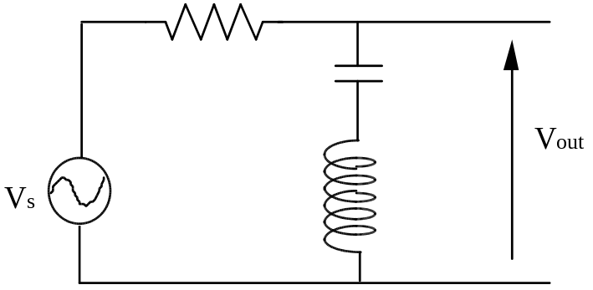
The bandstop filter rejects frequencies between the upper and lower cutoff frequencies, and passes those that are outside that range. This range of frequencies (between the upper and lower cutoffs) is called the stop band. This form of filter is also referred to as band-elimination filter, band-reject filter or a notch filter. The response curve is as shown
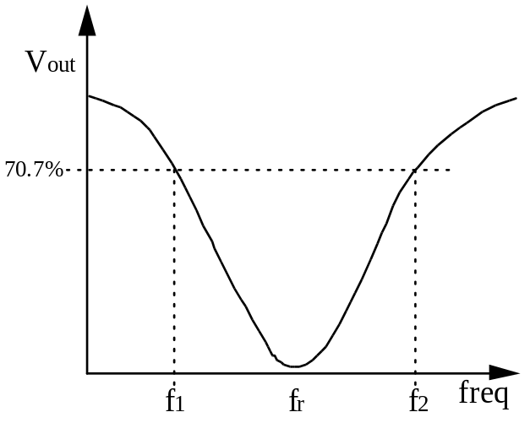
As the LC impedance decreases near resonance, the current increases, hence more of the voltage is dropped across the resistor, and therefore V_{out} decreases. As the frequency gets further from f_{r} the impedance increases, so more of the voltage is dropped over the output elements. The current response, impedance characteristics, bandwidth, selectivity and quality factor are equivalent to that for the bandpass filter, but the response curve is the opposite.
Parallel Resonant Band-Pass and Band-Stop RCL Filters
The basic parallel resonant band-pass filter is shown below.
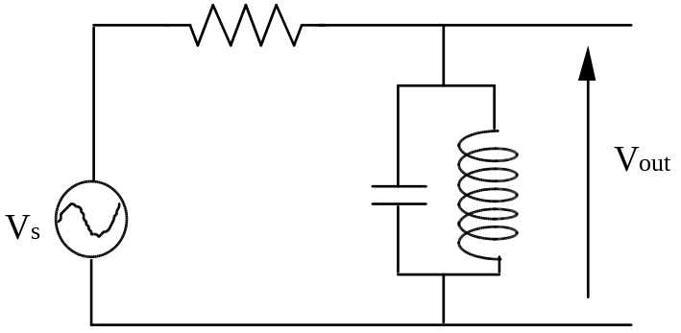
At the resonant frequency the impedance of the capacitor and inductor combination is a maximum, therefore the maximum voltage drop will occur at the output. When a resistive load is connected across the output of such a filter, the Q of the filter is reduced. Since bandwidth is inversely proportional to Q, it will be increased upon application of the load, and the selectivity decreased. This occurs due to the reduction of the impedance of the filter due to the load resistor effectively being in parallel with the circuit resistance.
The bandstop parallel filter is similar.
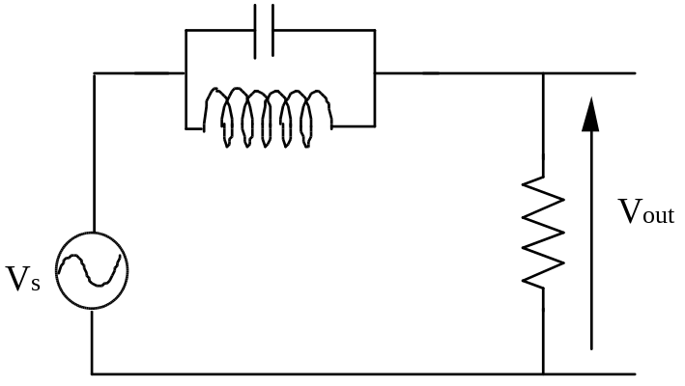
Now the current is a minimum at resonance, as is the output voltage. The output at resonance is given by
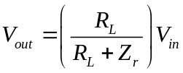
Rectifier Filters
You should have met an example of these in your year 2 electronics papers, consisting in its simplest form of a diode, capacitor and load resistor. Review this form of filter, as you are expected to be familiar with them, and I will not be providing additional notes.
Active Filters
Passive filters are based on capacitors, inductors and resistors. Active filters rely on the use of active devices such as transistors and op-amps - especially high input impedance FET op-amps. The main advantages of active filters over passive filters are
(i) Low Cost especially at low frequencies where passive filters require the use of large inductors
(ii) Isolation usually active filters have very high input impedances and very low output impedances. Thus their characteristics are independent of load and source impedance changes.
(iii) Cascadeability as they have good isolation, you can break down a complex filter into a simple one of several cascaded filters.
(iv) Gain can provide gain if required. Usually current gain is provided, but voltage gain can be designed in.
(v) Tuning can tune active filters over a 1:1000 frequency range without changing response curve shape. Tuning can be done electronically, manually or using voltage control of components.
(vi) Small size also small weight, especially at low frequencies where passive filters need large inductors.
(vii) No field sensitivity get few shielding and coupling problems
(viii) Ease of design often trivially easy using standard software packages
Disadvantages of active filters include
(i) Power supply not needed with passive filters
(ii) Signal limits op amps etc., set signal limits due to their input noise, dynamic range, high frequency response and their ability at handling large signals
(iii) Sensitivity variations in response are possible when component or op-amp tolerances shift with temperature
Note that it is sufficient to discuss all filter types in terms of a low-pass filter, as other filter types (bandpass, highpass etc.) are readily derived from them. With op-amps we are able to produce useful non-ideal filters with cut-offs in the < 0.1 Hz → 1 MHz range, above this it is usually better to use passive components.
Active Filter Types

We can never get the perfect filter. The linear amplitude response of the ideal lowpass filter is shown below.

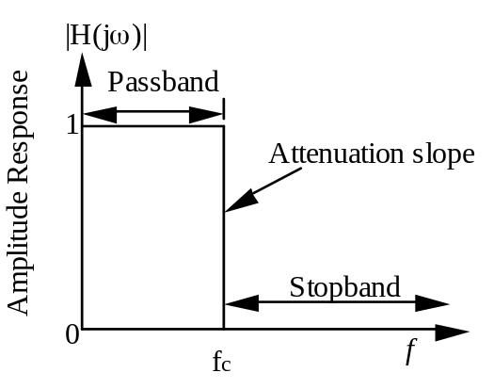

This ideal filter is characterized by zero loss and ripple in the passband, an infinite attenuation slope at the cutoff frequency f_{c} (i.e. a zero transition region), and an infinite attenuation in the stop band. In general, linear phase response is also assumed. However, such an ideal low-pass filter does not exist in practice, and we must implement suitable approximations. The best, and most common, are briefly described below. The gain is expressed in a logarithmic format to illustrate ripple behaviour in the stop band (for some filters) that would not be evident with a linear response.

a. Maximally Flat or Butterworth Filters
The maximally flat (or Butterworth) approximation of an ideal lowpass filter is shown below. This filter incorporates a maximally flat response in the passband, achieved at the expense of phase linearity and attenuation slope steepness in the transition region from passband to stopband.
The Butterworth is a commonly used filter as it provides an excellent general-purpose approximation to the ideal filter response. Although other filters may have superior phase linearity, impulse response or steepness of attenuation, none provide for all three as well as the Butterworth. The Butterworth is also employed when no ripple is desired in either the pass or stop bands.

The amplitude response is given by
=
b. Equiripple or Chebyshev Filters
Steepness of attenuation slope, especially in the region of cutoff, is often more important than passband flatness or phase linearity. In such cases the Chebyshev response is often preferred over the Butterworth. The Chebyshev filter exhibits increased overshoot when driven by a step function, and is designed so that ripples in the pass band never exceed a prescribed amount. To compensate for the lack of smooth response in the passband, there are advantages in a very much higher rate of cutoff around the edge of the passband.
Note that both Butterworth and Chebyshev lowpass filters achieve infinite attenuation only at infinite frequency, (where all the zeros of transmission occur). At any other frequency, some component of the signal, even though greatly attenuated, will pass through the filter. If infinite attenuation at particular frequencies are required, the inverse Chebyshev response may be used. In this situation, there is no ripple in the passband, but it does exist in the stopband (where certain frequencies are infinitely attenuated).

The amplitude is given by:
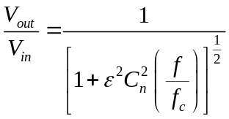
where C_{n} is the Chebyshev polynomial of the first kind of degree n, and ε is a constant that sets the passband ripple.

c. Elliptic or Chebyshev-Cauer Filters
Elliptic or Chebyshev-Cauer Filters have a very rapid descent to the maximum attenuation, achieved at the expense of introducing ripple in both passband and stopband. Like the inverse Chebyshev filter, certain frequencies are infinitely attenuated. Elliptic filters are probably the most efficient, in terms of component count, for approximating the amplitude response of an ideal filter. For a given filter order it is possible to produce filters more economically with either a very sharp cutoff or a very high attenuation in the stopband. However, the attenuation does not drop off smoothly to infinity outside the passband, but is maintained at a predetermined level. Note that Chebyshev and inverse Chebyshev filters are special cases of the more general Chebyshev-Cauer filter.

d. Linear-Phase or Bessel Filters
In the discussion so far, the emphasis has been on the amplitude response, however other factors must also be considered in filter design. When a rectangular pulse is passed through a Butterworth or Chebyshev filter, overshoot or ringing will appear on the pulse at the output. If this is undesirable, one of the members of the Gaussian family of filters can be used, the most common of which is the Bessel filter (so named because Bessel polynomials occur in the denominator of the transfer functions). If ringing or overshoot is to be avoided, the phase shift between the input and output of a filter must be a linear function of frequency. That is, the group delay (the rate of change of the phase with respect to frequency) must be constant. The Bessel filter provides the best approximation to the ideal of perfect flatness of the group delay in the passband, though is a markedly poorer approximation to the ideal of flatness in the passband and steepness of attenuation.

Time and Frequency Filter Descriptions
Bessel, Butterworth, Chebyshev
Filters can be characterised by two general descriptions: (i) the description of the gain and phase shift as a function of frequency and (ii) the description of the output waveform as a function of time. Filter behaviour in the time domain can most easily be understood by considering a step function input. For a perfect (not ideal) low-pass filter the output will be a rounded step function with no overshoot or ringing. The higher the filter break frequency, the shorter the rise time.
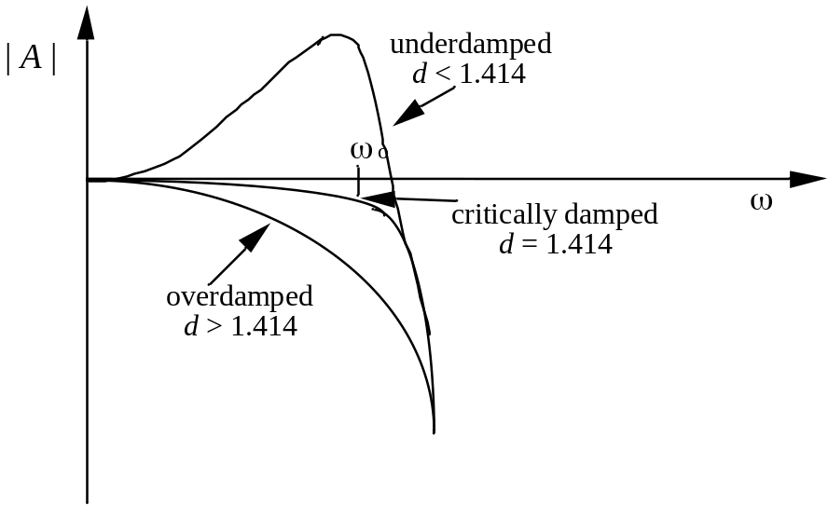
An underdamped mechanical oscillator will “ring” after being struck; common examples are a tuning fork, which is very underdamped, or a bell or a gong. A critically damped or overdamped oscillator will not ring or oscillate at all, corresponding to a damping factor of D ≥ . A ringing in the filter output corresponds to overshoot. The output rise time is also of interest - in general, the shorter the rise time, the better. Also, the settling time is of interest - the time for the filter output to settle down to its steady-state value - in other words, the time for the ringing to damp out to within a certain percentage of the steady-state value.
Note that in some texts, the damping factor D is replaced with a design gain factor K. The two are easily related by K = 3 - D. So D = is equivalent to K = 1.586. For the remainder of this section, the K values are given in brackets after the D values.
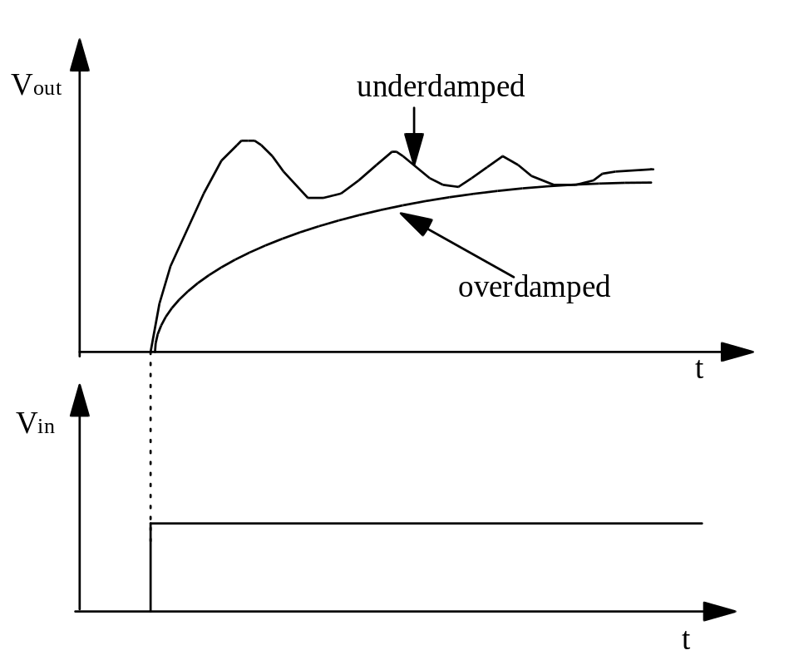
The value of the damping factor determines not only the shape of the filter gain versus frequency, but also the presence and amount of overshoot, ringing, and rise time in the time domain. In general, a large degree of underdamping (D << ) (K >> 1) produces significant ringing in the time domain and a large peak in the gain-versus-frequency curve at the break frequency. However, an underdamped filter does not, surprisingly, produce the shortest rise time. The most common underdamped filter is called a Chebyshev filter with a damping factor that varies according to the amount of tolerated ripple. It has the sharpest knee in the frequency domain - but at the cost of ripple in the passband gain - as shown below. It also has the worst overshoot in the time domain.

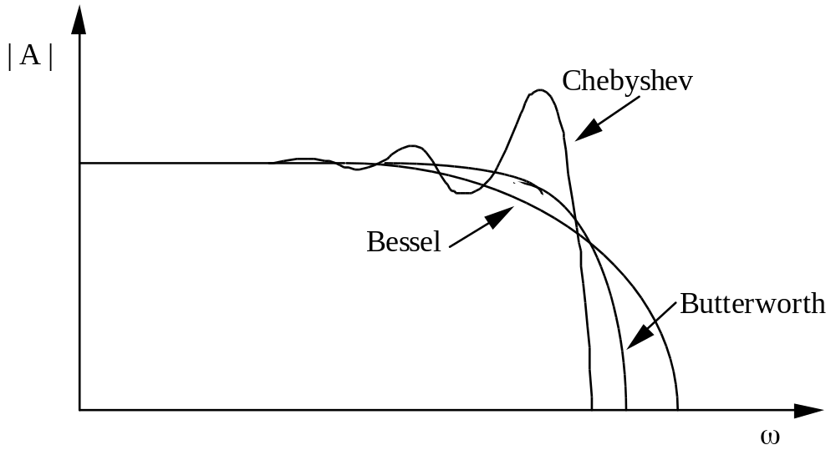

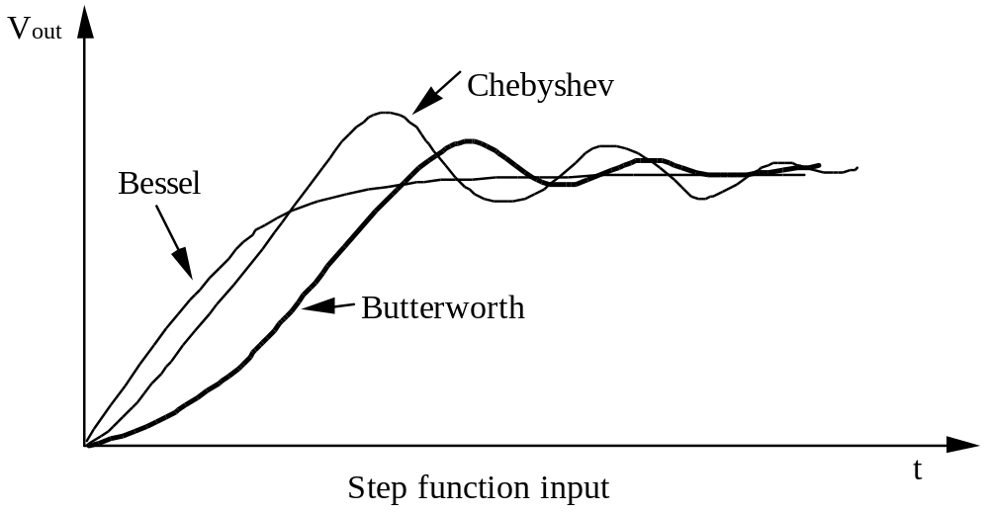

 |  |  |  |  | Settling time |  | Stopband attenuation
 | f_{3dB} |  | Step  rise time  (0 to 90%) | Over-  shoot | to 1% | to 0.1% | f=2f | f=10f
Type | (Hz) | Poles | (s) | (%) | (s) | (s) | (dB) | (dB)
Bessel | 1.0 | 2 | 0.4 | 0.4 | 0.6 | 1.1 | 10 | 36
(-3.0 dB at | 1.0 | 4 | 0.5 | 0.8 | 0.7 | 1.2 | 13 | 66
f= 1.0 Hz) | 1.0 | 6 | 0.6 | 0.6 | 0.7 | 1.2 | 14 | 92
 | 1.0 | 8 | 0.7 | 0.3 | 0.8 | 1.2 | 14 | 114
Butterworth | 1.0 | 2 | 0.4 | 4 | 0.8 | 1.7 | 12 | 40
(-3.0 dB at | 1.0 | 4 | 0.6 | 11 | 1.0 | 2.8 | 24 | 80
f= 1.0 Hz) | 1.0 | 6 | 0.9 | 14 | 1.3 | 3.9 | 36 | 120
 | 1.0 | 8 | 1.1 | 16 | 1.6 | 5.1 | 48 | 160
Chebyshev | 1.39 | 2 | 0.4 | 11 | 1.1 | 1.6 | 8 | 37
0.5 dB ripple | 1.09 | 4 | 0.7 | 18 | 3.0 | 5.4 | 31 | 89
(-0.5 dB at | 1.04 | 6 | 1.1 | 21 | 5.9 | 10.4 | 54 | 141
f= 1.0 Hz) | 1.02 | 8 | 1.4 | 23 | 8.4 | 16.4 | 76 | 193
Chebyshev | 1.07 | 2 | 0.4 | 21 | 1.6 | 2.7 | 15 | 44
2.0 dB ripple | 1.02 | 4 | 0.7 | 28 | 4.8 | 8.4 | 37 | 96
(-2.0 dB at | 1.01 | 6 | 1.1 | 32 | 8.2 | 16.3 | 60 | 148
f= 1.0 Hz) | 1.01 | 8 | 1.4 | 34 | 11.6 | 24.8 | 83 | 200

Table 1
The critically damped filter is called the Butterworth filter with a damping factor D = 1.414 (K = 1.586). It has the flattest pass band - the flattest gain versus frequency with no ripples in the frequency domain - but it has overshoot in the time domain in response to step inputs.
The most common overdamped filter is the Bessel filter with D = 1.728 (K = 1.272). It has the roundest knee of the gain versus frequency, but it has the best transient response, with the shortest rise time and no overshoot or ringing.
For frequencies well above the break frequency for all three types of low-pass second-order filters, the gain falls off at the same rate, namely 40 dB/decade or 12 dB/octave (as f ^{–2}). All of these op amp active filters have high input impedances and low output impedances, so they can be cascaded to yield higher-order filters.
Cascading several second-order active filters is possible because of their high input and low output impedances, but some problems do arise. For example, consider two low-pass second-order 1 kHz Butterworth filters, each with a damping factor of 1.414 (K = 1.586) and a 3 dB point of 1.0 kHz. If they are cascaded in series, the 3 dB point of the resultant fourth-order filter is less than 1.0 kHz, and the gain is down by 6 dB at 1.0 kHz; in other words, the knee of the fourth-order filter is rounded off even though its gain drops off at -24 dB/octave (f ^{–4}) for frequencies well above 1.0 kHz. To make a true Butterworth fourth-order filter with a 3 dB cutoff frequency at 1.0 kHz requires that we cascade an overdamped second-order 1.0 kHz filter with an underdamped second-order 1.0 kHz filter as shown below. Careful gain calculations indicate each filter should have a cutoff frequency of 1.0 kHz, and the damping factor of the first filter should be 1.848 (K = 1.152) and that of the second filter 0.765 (K = 2.235). In general, the filter nearest the input should have the highest damping factor.
The design of active filters is often done using an engineering approach. Usually an arrangement of capacitors and resistors and an op-amp is known i.e. the suggestion from your handouts, to produce a filter of a required type. The resistor and capacitor values are chosen in certain ratios from design data to give the required characteristics (rate of fall-off, amount of ripple etc). The actual values are then determined by arbitrarily selecting some values (e.g. resistors set to ≈ 10 kΩ or 100 kΩ) and the rest are then calculated according to the appropriate ratios desired.
A technique called scaling can be used to determine new resistors and capacitor values required to provide a new filter with the same shaped response function but different frequency cut-offs or impedance levels. Impedance level is increased by multiplying all resistors and dividing all capacitors by the required level. Frequency is shifted by dividing all resistor values, or all frequency-determining capacitors by the desired factor of frequency increase. If both resistors and capacitors were divided, then the frequency will shift by the square of the desired factor!
For cascaded Bessel or Chebyshev filters the cutoff frequencies of the two filters and also the damping factors are different. For example, a fourth-order 1.0 kHz cutoff Chebyshev 2 dB ripple filter consists of two second-order filters - the first with a cutoff frequency of 471 Hz and a damping factor of 1.076 (K = 1.924), and the second with a cutoff of 964 Hz and a damping factor of 0.218 (K = 2.782).
As a general rule, the more underdamped the filter (the smaller D), the higher the precision of the R and C components to avoid the possibility of filter oscillation. For example, 10% tolerance components may be adequate for the overdamped Bessel filter, whereas 1 or 2% tolerance might be required for the underdamped 2 dB Chebyshev filters.
The Bessel filter is best for minimum ringing in response to sudden changes in the input amplitude; the Chebyshev filter has the sharpest knee but the worst transient behaviour; and the Butterworth filter is a compromise between a sharp knee and minimum ringing.
The values of the R₁ C₁ and R₂ C₂ are fixed by the cutoff frequencies of the two stages. Whether we use a large R and a small C or vice versa depends on the desired filter input impedance. In general, the first filter input impedance should be large compared to the input signal source output impedance. It can be shown that the filter input impedance is approximately given by Z = 5/ω₀ C = 5 |X_{c}|. Thus, choosing C₁ determines the first filter input impedance and choosing C₂ determines the second filter input impedance. Then the break frequency ω₀ = 1/R₁ C determines R₁. Resistance values greater than about 100 kΩ tend to be noisy and unreliable, so a good rule is to use resistances from 1 kΩ to 100 kΩ. Such filter designs are discussed in a later section.
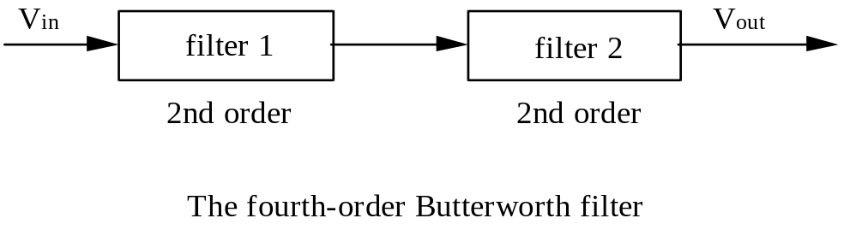

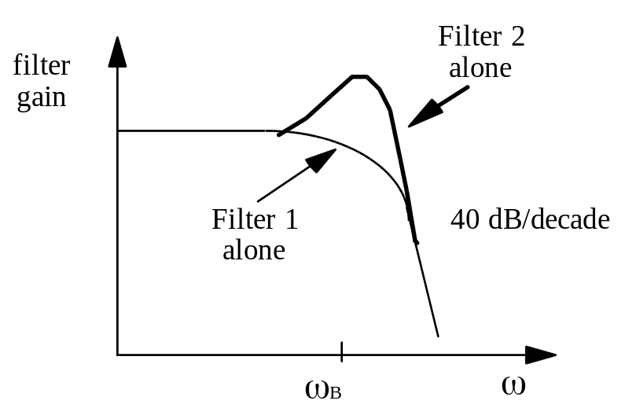

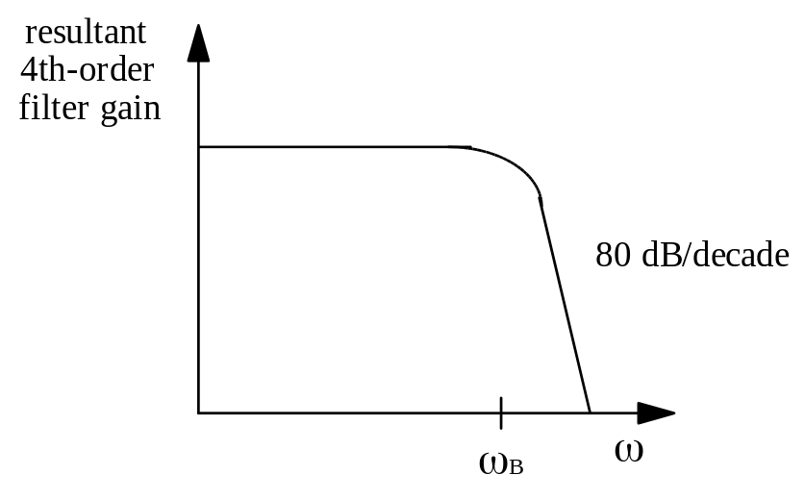
Design of Active Filters
Below is a basic first order active filter and its response curve. The input circuit is a single low-pass RC network, and unity gain is provided by the op-amp with a negative feedback loop. Effectively this is a voltage follower with an RC filter between the input signal and the noninverting input.
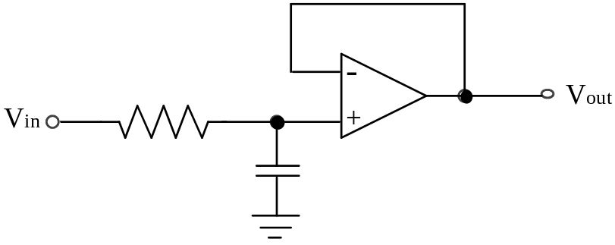

The voltage at the noninverting input is
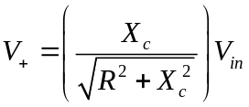
Since the gain of the op-amp is 1, the output voltage is equal to V+. A filter with one RC network that produces a -20 dB/decade roll-off beginning at f_{c} is said to be a single-pole or first-order filter. The term “-20 dB/decade” means that the voltage gain decreases by ten times (-20 dB) when the frequency increases by ten times (decade).
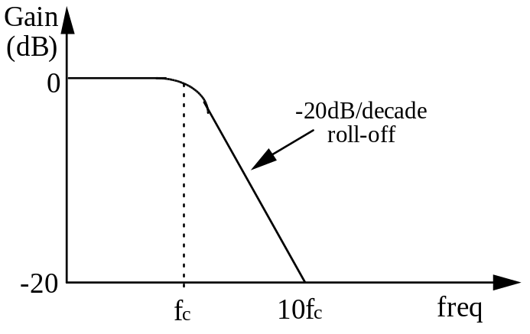

There is often very little point in designing a first order filter, as a second order one, with superior characteristics can be created using the same number of op-amps.
Low-Pass Second Order Filters
Below is a second-order VCVS (Voltage Controlled Voltage Source) low pass filter. Since each RC network in a filter is considered to be one-order, this second order filter uses two RC networks to produce a roll-off rate of -40 dB/decade. The active filters have a gain depending upon the ratio of the resistors connected to the inverting terminal. Unity gain up to near f_{c} is achieved by replacing these resistors with a wire between V_{out} and the inverting terminal (with open circuit to ground), to give the response indicated in the figure after the circuit shown below. Note that we are using K in the filter design, rather than the damping factor D.
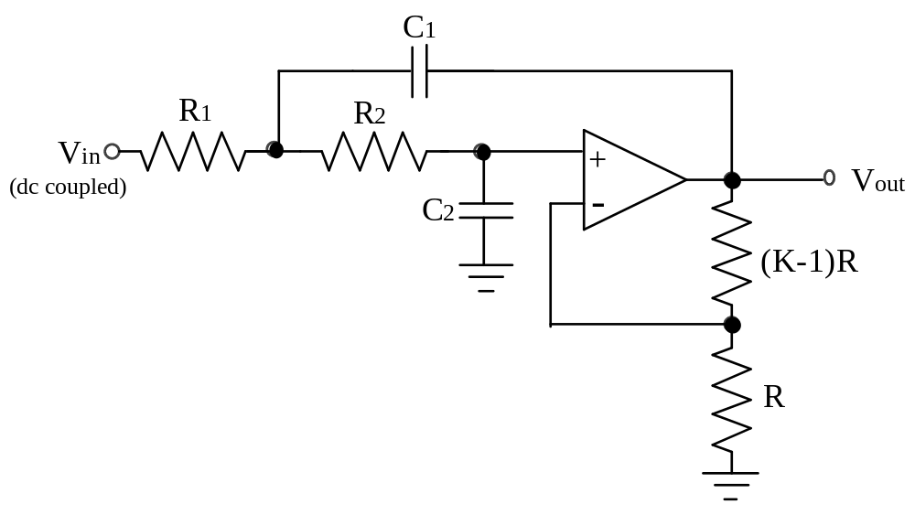

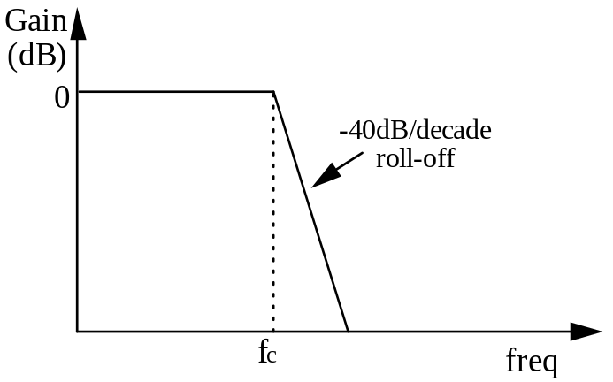
One of the RC networks is formed by R₁ and C₁, and the other by R₂ and C₂. The critical frequency of this filter can be calculated by
f=
or when R₁ = R₂ and C₁ = C₂ then
f=
The high pass filter (both first and second order) is equivalent to the low pass with the capacitors and resistors swapped and the response curve reversed as in the figures below.
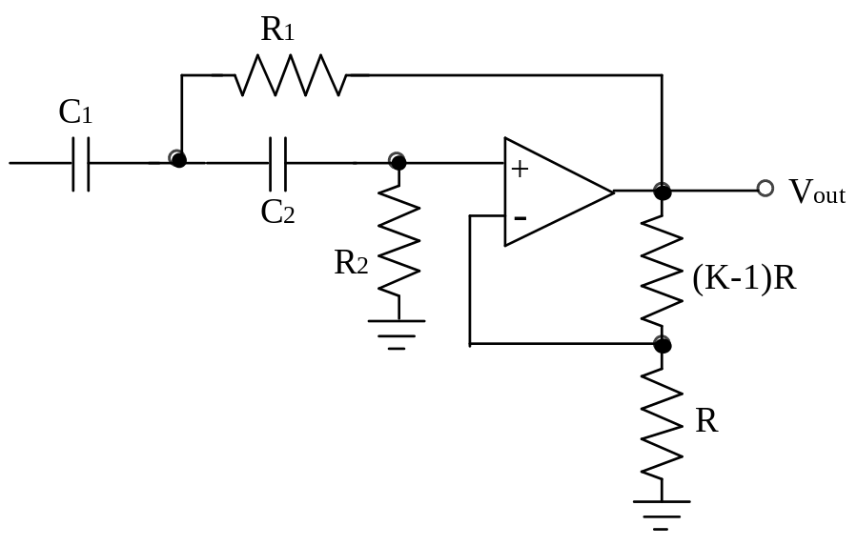
Ideally, a high-pass filter passes all frequencies above f_{c} without limit. In practice this is not the case as all op-amps inherently have internal RC networks that limit the amplifier’s response at high frequencies (see later). With the active high-pass filter there is an upper frequency limit to its response, which essentially makes this type of filter a wide band-pass filter rather than a true high-pass filter. In many applications, this internal high-frequency cutoff is so much greater than the filter’s f_{c} that it can be neglected.
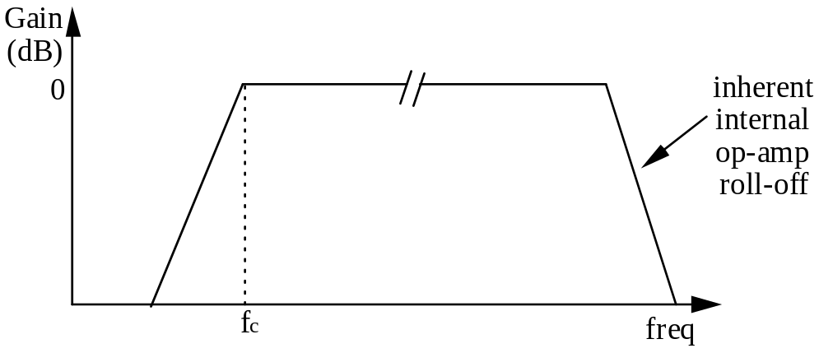
Band-Pass Filter
One way to implement a band-pass filter is to use a cascaded (joined) arrangement of a high-pass filter followed by a low-pass filter. For example, a second order low pass filter could be connected to a second order high pass filter, and the critical frequency of each filter chosen so that the response curves overlap.
The critical frequency of the high-pass filter is obviously lower than that of the low-pass filter. The lower frequency f_{c1} of the pass band is set by the critical frequency of the high-pass filter. The upper frequency f_{c2} of the pass band is the critical frequency of the low-pass filter. Ideally, the centre frequency f_{r} of the pass band is the geometric average of f_{c1} and f_{c2} . Note that the order in which the filters are cascaded does not matter.
f=
f=
f=
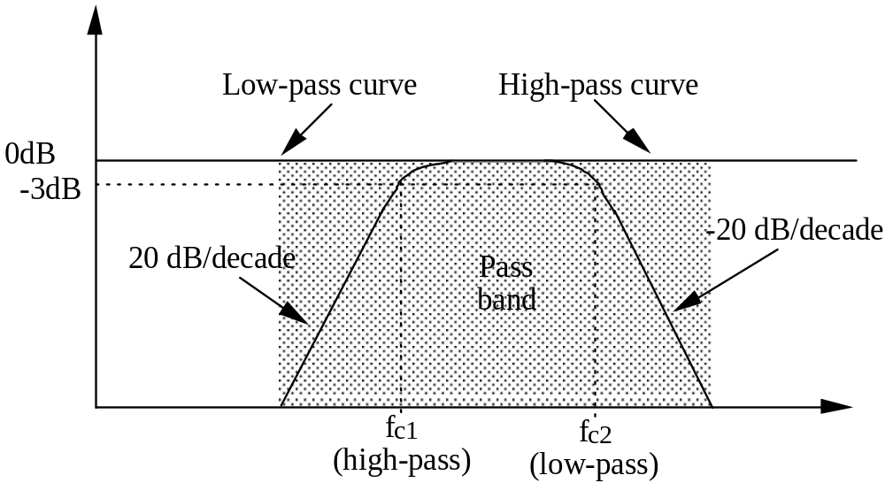
This overlapping of low and high pass filters is most useful when there is a large frequency range to be covered, e.g. phone bandwidth (300 Hz - 3000 Hz). Rather than cascade two discrete filters, it is also possible to create a band pass filter with one op-amp, by combining the characteristics of the low pass and high pass RC configurations, i.e.
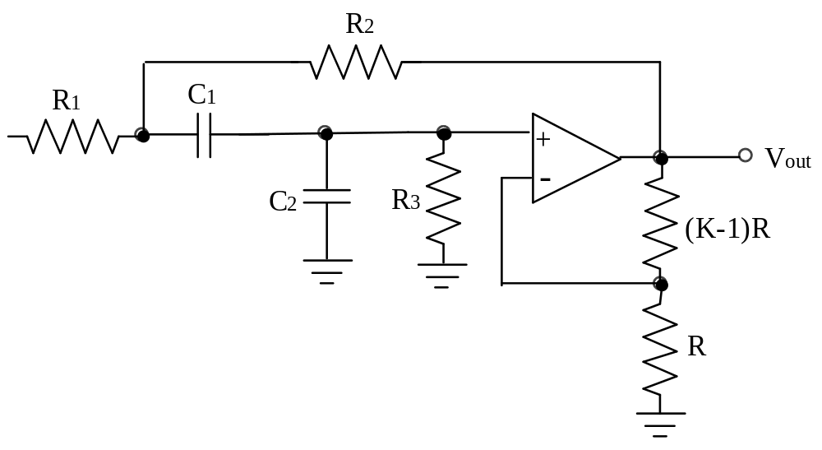
where
f=
or if R= R= R= R and C= C= C then

f=
We will now consider some first, second and higher order low pass filters. Note that the circuits given are not the only possible ways of using R's, C's and op-amps to make low pass filters. Many others are possible.
First Order Low Pass Filter
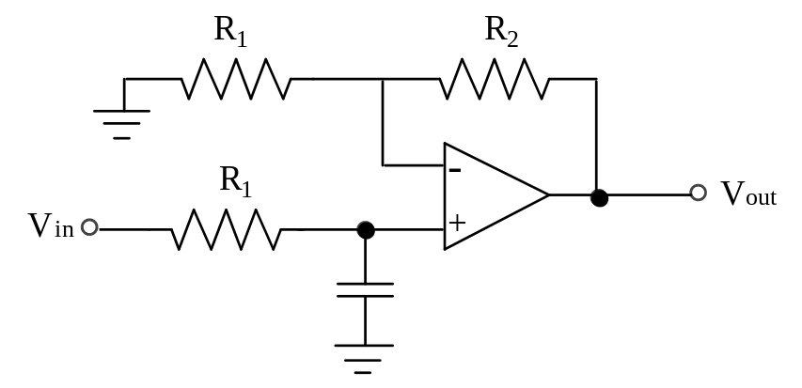
Consider first the transfer function of the RC network
=
The output V₊ is amplified by the non-inverting feedback arrangement, thus the system transfer function is
H(jω) =
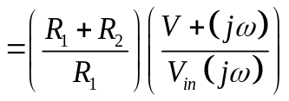
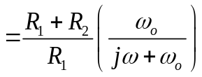
where ω=
Thus we have a low pass filter, with cutoff frequency ω, and gain .
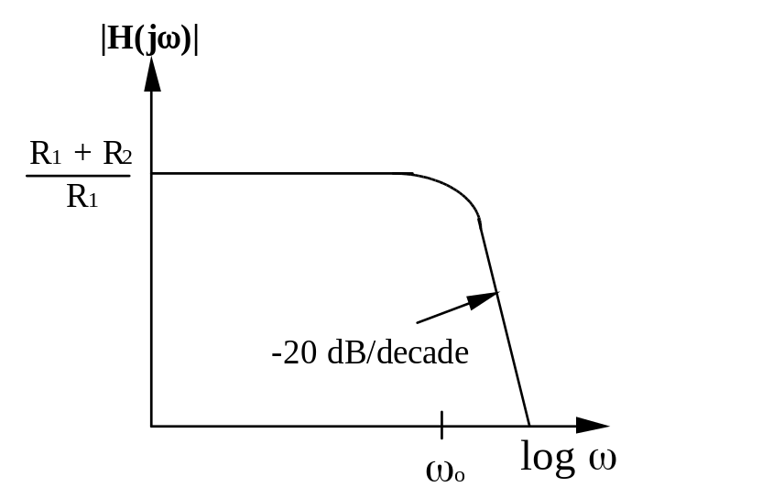
Design
Suppose we want f_{o} = 10 kHz, and a gain of 3. Choose R₁ = 100 kΩ (arbitrary),
⇒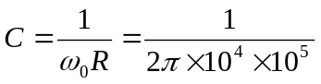
= 160 pF
For a gain of 3,
= 3
⇒ R= 2R= 200 kΩ
VCVS Circuits
The voltage controlled voltage-source (VCVS) filter, also known simply as a controlled-source filter, is a variation of the Sallen and Key filter. It can have a gain greater than 1. Figures showing the construction of second order low-pass, high-pass and band-pass filters have been provided earlier, and the low pass is presented again below.
Second Order VCVS Low Pass Filter
The resistors at the output of the op-amp create a noninverting voltage amplifier of voltage gain K, with the remaining R’s and C’s contributing the frequency response properties for the filter. These are second order filters, and they can be Butterworth, Bessel, etc., by suitable choice of component values. Any number of VCVS second order sections may be cascaded to generate higher-order filters. When that is done, the individual filter sections are, in general, not identical. In fact, each section represents a quadratic polynomial factor of the nth order polynomial describing the overall filter.
To use the table below, begin by deciding which filter response you need. As mentioned, the Butterworth may be attractive if maximum flatness of passband is desired, the Chebyshev gives the faster fall-off from passband to stopband (at the expense of some ripples in the passband), and the Bessel provides the best phase characteristics, i.e., constant signal delay in the passband, with correspondingly good step response.
Order | Butter-  worth | Bessel |  | Chebyshev  (0.5 dB) |  | Chebyshev  (2.0 dB)
 | K | f_{n} | K | f_{n} | K | f_{n} | K
2 | 1.586 | 1.272 | 1.268 | 1.231 | 1.842 | 0.907 | 2.114
4 | 1.152 | 1.432 | 1.084 | 0.597 | 1.582 | 0.471 | 1.924
 | 2.235 | 1.606 | 1.759 | 1.031 | 2.660 | 0.964 | 2.782
6 | 1.068 | 1.607 | 1.040 | 0.396 | 1.537 | 0.316 | 1.891
 | 1.586 | 1.692 | 1.364 | 0.768 | 2.448 | 0.730 | 2.648
 | 2.483 | 1.908 | 2.023 | 1.011 | 2.846 | 0.983 | 2.904
8 | 1.038 | 1.781 | 1.024 | 0.297 | 1.522 | 0.238 | 1.879
 | 1.337 | 1.835 | 1.213 | 0.599 | 2.379 | 0.572 | 2.605
 | 1.889 | 1.956 | 1.593 | 0.861 | 2.711 | 0.842 | 2.821
 | 2.610 | 2.192 | 2.184 | 1.006 | 2.913 | 0.990 | 2.946

Table 2
To construct an nth order filter (n is an even number), you will need to cascade n/2 VCVS sections. Only even-order filters are shown, since an odd-order filter requires as many op-amps as the next higher-order filter. Within each section R₁ = R₂ = R, and C₁ = C₂ = C. As is usual in op-amp circuits, R will typically be chosen in the range 10 k to 100 kΩ. (It is best to avoid small resistor values, because the rising open-loop output impedance of the op-amp at high frequencies adds to the resistor values and upsets calculations.) Then all you need to do is set the gain, K, of each stage according to the table entries. For an n-order filter, there are n/2 entries, one for each section.
Butterworth low-pass filters
If the filter is a Butterworth, all sections have the same values of R and C, given simply by RC = 1/2πf_{c} where f_{c} is the desired -3 dB frequency of the entire filter. To make a 6th order low-pass Butterworth filter, for example, you cascade three of the low-pass sections shown previously, with gains of 1.07, 1.59, and 2.48 (preferably in that order, to avoid dynamic range problems), and with identical R’s and C’s to set the 3 dB point.
Bessel and Chebyshev low-pass filters.
To make a Bessel or Chebyshev filter with the VCVS, the situation is only slightly more complicated. Again we cascade several second order VCVS filters, with prescribed gains for each section. Within each section we again use R₁ = R₂ = R, and C₁ = C₂ = C. However, unlike the situation with the Butterworth, the RC products for the different sections are different and must be scaled by the normalising factor f_{n} (given for each section in the table) according to RC = 1/2πf_{n} f_{c} . Here f_{c} is again the -3 dB point for the Bessel filter, whereas for the Chebyshev filter it defines the end of the passband, i.e., it is the frequency at which the amplitude response falls out of the ripple band on its way into the stopband. For example, the response of a Chebyshev low-pass filter with 0.5 dB ripple and f_{c} = 100 Hz will be flat within +0 dB to -0.5 dB from dc to 100 Hz, with 0.5 dB attenuation at 100 Hz and a rapid fall-off for frequencies greater than 100 Hz. Values are given for the Chebyshev filters with 0.5 dB and 2.0 dB passband ripple; the latter have a somewhat steeper transition into the stopband.
High-pass filters
To make a high-pass filter, use the high-pass configuration shown previously. For the Butterworth filters, everything else remains unchanged (use the same values for R, C, and K). For the Bessel and Chebyshev filters, the K values remain the same, but the normalizing factors f_{n} must be inverted, i.e., for each section the new f_{n} equals 1/(f_{n} listed in the table).
High Pass Filters
First Order High Pass Filter
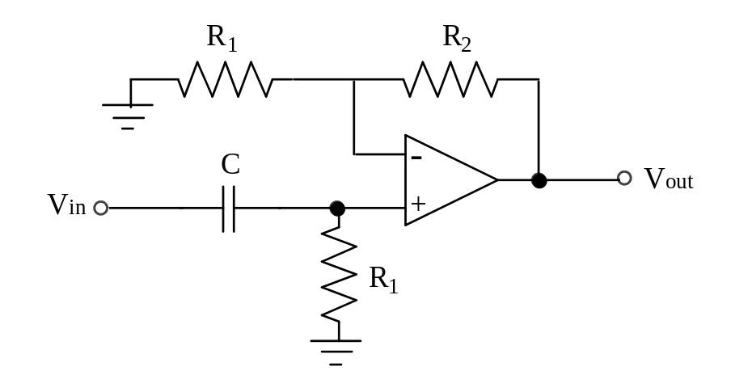
As with the first order low pass filter, this is effectively a passive high pass filter followed by a non-inverting amplifier. The transfer function is easily calculated as
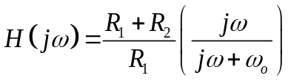
The design of VCVS filters proceeds as described above.
A bandpass filter can be made by cascading overlapping low-pass and high-pass filters. A band-reject filter can be made by summing the outputs of nonoverlapping low-pass and high-pass filters. However, such cascaded filters won’t work well for high-Q filters (extremely sharp bandpass filters) because there is great sensitivity to the component values in the individual (uncoupled) filter sections. In such cases a high-Q single-stage bandpass circuit (e.g., the VCVS bandpass circuit illustrated previously) or the state-variable and biquad filters should be used instead. Even a single stage second order filter can produce a response with an extremely sharp peak.
Filter Design Examples
Example 1: To construct a Butterworth low-pass filter
(1) Determine the order necessary based on the required roll-off rate. Choose an even number, as an odd number will require the same number of op-amps as the next-highest even number. For example, if the required fall-off is -40 dB/decade, specify a second order filter.
(2) Choose R and C values for the desired cutoff frequency. The resistors should be between 1 kΩ and 100 kΩ as discussed previously. The value chosen should satisfy the cutoff frequency, as given by f = 1/2πRC.
(3) Choose resistors R₁ and R₂ that produce the gain for each section according to the values listed in Table 2.
A low-pass Butterworth filter with a roll-off of approximately -80 dB/decade and a cutoff frequency of 2.0 kHz is required. Specify the components.
Step 1: Determine the number of poles required. Since the design requirement is for approximately - 80 dB/decade, a fourth order (two-section) filter is required.
Step 2: Choose R and C. Try C as 0.01 µF and compute R. Computed R = 7.96 kΩ. The nearest standard value to this is 8.2 kΩ.
Step 3: Determine the gain required for each section and specify the value of these resistors. From Table 2, the gain of Section 1 is required to be 1.152 and the gain of Section 2 is required to be 2.235. Arbitrarily set R of Section 1 to be 10 kΩ, then (K - 1)R is 1.5 kΩ. The gain of Section 2 is 2.235, so (K - 1)R = 1.235R, and standard values that give approximately this ratio is R = 22 kΩ and (K - 1)R = 27 kΩ. The completed circuit is shown below.
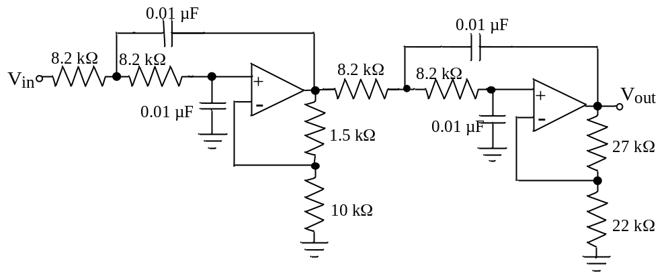
Example 2: Design a second order lowpass 2 dB ripple Chebyshev filter with a cutoff frequency of 10 kHz.
RC =
Semi-arbitrarily choose R = 10⁴ Ω
⇒ C = 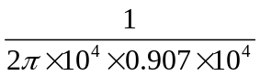= 1.75 × 10F
The gain ratio is K = 2.114 so (K - 1) = 1.114
if R = 10⁴ Ω, then (K - 1)R = 11 kΩ
∴ filter is
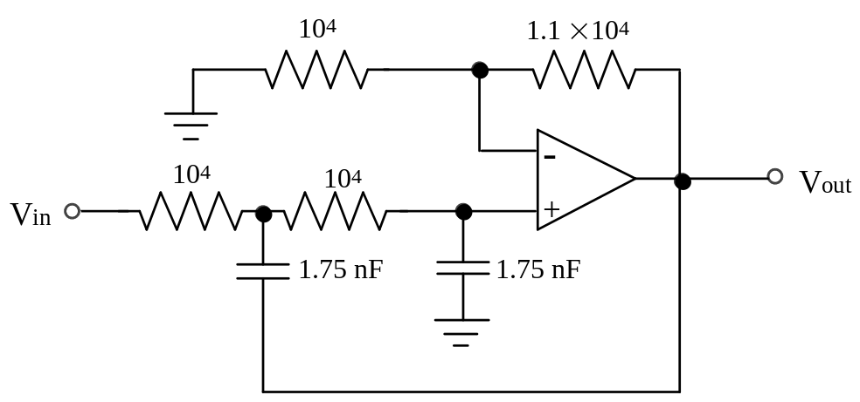
State Variable Filter
The second order state variable filter is far more complex than the VCVS circuits, but it is popular because of its improved stability and ease of adjustment. It is called a state-variable filter and is available as a complete IC. Because it can come in a manufactured module, all components except R_{G}, R_{Q} and the two R_{F}’s are built in. Among its nice properties is the availability of high-pass, low-pass and bandpass outputs from the same circuit; also, its frequency can be tuned while maintaining constant Q (or, alternatively, constant bandwidth) in the bandpass characteristic. As with the VCVS realizations, multiple stages can be cascaded to generate higher-order filters.
Extensive design formulas and tables are provided by the manufacturers for the use of these convenient ICs. They show how to choose the external resistor values to make Butterworth, Bessel and Chebyshev filters for a wide range of filter orders, for low-pass, high-pass, bandpass and band reject responses. Among the nice features of these hybrid ICs is integration of the capacitors into the module, so that only external resistors need be added.
State Variable Bandpass filters
The state-variable circuit, in spite of its large number of components, is a good choice for sharp (high Q) bandpass filters. It has low component sensitivities, does not make great demands on op-amp bandwidth, and is easy to tune. For example, in the circuit above, used as a bandpass filter, the two resistors R_{F} set the centre frequency, while R_{Q} and R_{G} together determine the Q and band-centre gain;
R= 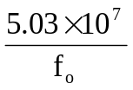Ω
R= Ω
R= 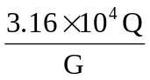Ω
So you could make a tunable frequency constant Q filter by using a 2-section variable resistor for R_{F} . Alternatively, you could make R_{Q} adjustable, producing a fixed-frequency, variable Q (and, unfortunately, variable gain) filter.
The state variable filter has three outputs - one highpass, one bandpass and one low pass. The circuit is
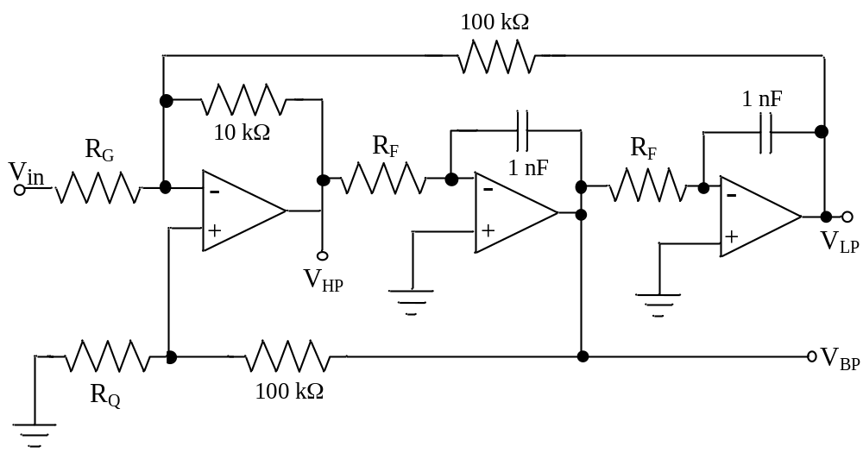
High Q’s (up to 500) are possible with this circuit.
Biquad filter
A close relative of the state variable filter is the so-called biquad filter. This circuit also uses three op-amps and can be constructed from the state-variable ICs mentioned earlier. It has the interesting property that you can tune its frequency (via R_{F}) while maintaining constant bandwidth (rather than constant Q). Here are the design equations:
f=
BW =
G =
The Q is given by f_{o} /BW and equals R_{B} /R_{F} . As the centre frequency is varied (via R_{F}), the Q varies proportionately, keeping the bandwidth Qf_{o} constant.
When you design a biquad filter from scratch (rather than with an active filter IC that already contains most of the parts), the general procedure is:
(1) Choose an op-amp whose bandwidth f_{T} is at least 10 to 20 times Qf_{o} .
(2) Pick a round number capacitor value in the vicinity of
C = µF
(3) Use the desired centre frequency to calculate the corresponding R_{F} from the first equation given earlier.
(4) Use the desired bandwidth to calculate R_{B} from the second equation given earlier.
(5) Use the desired band-centre gain to calculate R_{G} from the third equation given earlier.
You may have to adjust the capacitor value if the resistor values become awkwardly large or small. For instance, in a high-Q filter you may need to increase C somewhat to keep R_{B} from becoming too large. Note that R_{F}, R_{G} and R_{B} act as op-amp loads, and should not become less than, say 5 kΩ. When juggling component values, you may find it easier to satisfy requirement 1 by decreasing integrator gain (increase R_{F}) and simultaneously increasing the inverter stage gain (increase the 10 kΩ feedback resistor).
Higher Q’s can be obtained by cascading several VCVS stages. Alternatively, high Q circuits (up to 500) may be constructed with op-amp second order stages which use multiple op-amps such as the biquad filter.
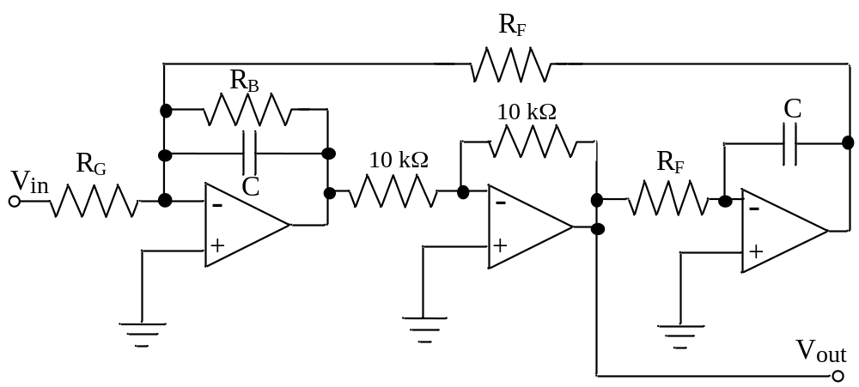
Digital Filtering
Digital filtering is one of the most important types of digital signal processing. The main advantage of a digital filter compared to an analogue filter is that the filter characteristics (bandpass, centre frequency, etc) can be changed merely by changing the software. The disadvantages are that the digital filter characteristics change with changes in the clock frequency, and the mathematics can be rather complex.
In the general case, the output of the filter is some amplitude y_{n} , which depends upon some input values x_{n} , and possibly on some of the previous output values. That is, in the general case the digital filter output is
y= +
where a_{k} and b_{k} are constants. The choices of these constants determine the type of filter (e.g. low pass, high pass, etc). As all circuits we will be dealing with are causal, the inputs start at time = zero, and a previous output does not exist until after the first sample.
There are two general types of digital filters: recursive and non-recursive. The nonrecursive filter is one in which the output y_{n} depends only on the inputs x_{n}, and not on any of the outputs. In other words there is no feedback from past outputs to the present output. These filters are also called finite impulse response filter (FIR), transversal filter, tapped delay line filter, and a moving average filter. The last name can perhaps make the most sense, for example:
y= ax+ ax+ ax
If all the constants equal one third, then the output is simply the arithmetic average of the present input and the previous two inputs:
y=
Such an averaging process tends to smooth out any rapid fluctuations in the input x, and thus would act something like a low pass filter.
The recursive filter has an output that depends on both the inputs x_{n} and the outputs y_{n} . Other names for this form of filter include infinite impulse response (IIR) filter, ladder filter, lattice filter, wave digital filter and autoregressive moving filter.

i.e. in a hardware implementation, for a given number of active and passive components, an elliptic filter design will generally exhibit superior filter characteristics to any of the others discussed.

